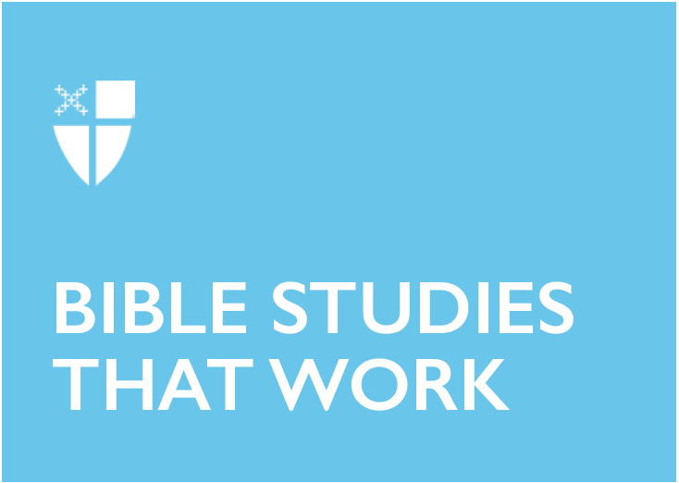

Pentecost 19 - Proper 24 (C)
October 20, 2019

RCL: Jeremiah 31:27-34; Psalm 119:97-104; 2 Timothy 3:14-4:5; Luke 18:1-8

Jeremiah 31:27-34
This passage echoes the charge given to Jeremiah when God called him to the work of a prophet: “to pluck up and break down, to overthrow, destroy, and bring evil… to build and to plant” (Jeremiah 3:28, NRSV; cf. Jeremiah 1:10). Jeremiah sees and proclaims that the situation of his people is dire and that the day of reckoning is near. But this is a text of hope; God will not allow destruction to have the last word. In this passage, Jeremiah sets out a vision of God’s continuing commitment to God’s people, despite the fact that they have abandoned God like an unfaithful spouse. God’s irrepressible love for Israel - and for us - overcomes all, and Jeremiah proclaims the restoration of an exiled people to a newly fertile homeland. In the renewed covenant, God’s people know and love God’s laws so well that they become second nature, or better still, first nature.

- Where do you see God making good on the promise of a renewed, intimate relationship with you? With the Church? With the world?

Psalm 119:97-104
Psalm 119 is famously focused on the love of the Torah - God’s revelation given to the Jewish people in the first five books of the Bible, here referred to as “law” and “commandment.” Many Christians are quick to hear these words and think of a rigid set of rules, with God as some kind of supernatural taskmaster, waiting for us to make a mistake. But this is not how the psalmist has received the Torah; this passage is not about the results the psalmist hopes for, or an arrogant boast about her piety. If we read this passage as a song of thanksgiving and joy, we hear the psalmist describing what happens when we pattern our lives around God’s way of love: we gain wisdom and insight and have the strength not to act in destructive ways. Taken together with our reading from Jeremiah, we begin to see a fuller picture of what God’s dream for us and for the world looks like.

- How are you patterning your life around God’s way of love?

2 Timothy 3:14-4:5
This letter is written to exhort and encourage the young leader of an early Christian congregation, and today’s passage forms a climax of sorts, as Paul encourages Timothy to not only follow the example of his mentor but also to stand firm in the faith and traditions that have been passed on to him. Timothy would have been familiar with scripture (which to him would have been the books we now call the Old Testament), but much of the teachings of Jesus and the meaning of his resurrection were still being passed on orally. Paul and others devoted their lives to testifying to how their lives had been forever changed by encountering the resurrected Jesus. For Timothy, then, the charge is to remain faithful to this truth and in continuing to pass it on. Paul acknowledges that there will be those within the Christian community who trade their baptismal commitments for ways of thinking that more quickly satisfy or that stroke the ego, but along with Timothy, our task is to keep a clear vision of who we are in Christ and continue to proclaim the life-changing work of God through Jesus - the reason the Church exists at all.

- How has the good news of the Resurrection been passed on to you? How are you passing it on to others?

Luke 18:1-8
“Jesus told them a parable about their need to pray always and not to lose heart… ‘And yet, when the Son of Man comes, will he find faith on earth?’” (Luke 18:1, 8). What seemed to be fairly innocuous teaching about prayer takes on an unexpected character when Jesus mentions the end of the age. For context, the section that appears before this parable in Luke’s Gospel is helpful, and we see that today’s reading forms the second part of a teaching that began in chapter 17: “The days are coming when you will long to see one of the days of the Son of Man, and you will not see it” (Luke 17:22). Jesus’ teaching on the value of persisting in prayer is not to say that we should badger God until we get what we want, like the widow. Rather we are invited to consider that if even finite humans are capable of getting around to justice (even if for the wrong reasons), how much more is God ready to establish the justice of God’s kingdom? Today’s readings paint a picture of a God who has promised to establish a world where all live justly and in intimate relationship with God. They encourage us to stand firm in our faith in that promise while continuing to pray for its fulfillment.

- Every Sunday, we pray, “thy kingdom come, thy will be done.” What does it look like to persevere in praying for this in ways that are specific to your community?

Hailing from the Episcopal Diocese of Pennsylvania, Noah Stansbury is a middler at the School of Theology at the University of the South. He is an Episcopal Service Corps alumnus and holds a bachelor’s degree in biblical studies. Two of his great loves are cats and collecting books he will never have time to read.

