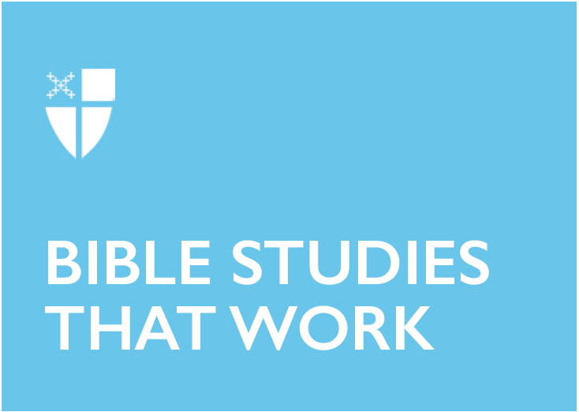

**Pentecost 22 - Proper 27 (C)**

**November 10, 2019**

**RCL: Haggai 1:15b-2:9; Psalm 145:1-5, 18-22 or Psalm 98; 2 Thessalonians 2:1-5, 13-17; Luke 20:27-38**

**Haggai 1:15b-2:9**

It is helpful to read all of chapter 1 of the book of Haggai through 2:9 to obtain a fuller sense of what is going on in this passage. Haggai was a prophet who urged the leaders of Judah and the Judean people to rebuild the temple in Jerusalem. The text itself, in verse 1:15, shares that the book was written in the year 520 BCE, during the second year of the reign of the Persian emperor Darius I. This dating tells us that it had been 19 years since the Judean people returned from their Babylonian exile. Since their return, they apparently have been building their own houses while neglecting to rebuild the Lord’s house, the Temple (Haggai 1:9), which was destroyed in 587 BCE.

The community listens to the divine command from Haggai and obeys—they do indeed begin to rebuild the Temple. Our passage for today is God’s response to the obedience and faithfulness of the Judean people in following the Lord’s command. God reminds the people that although the Temple has been destroyed and rebuilding it will be difficult, God’s presence with them is steadfast, as it always has been, even through times of great difficulty, like their exiles in Egypt and in Babylon. “My spirit abides among you,” God tells the people, “do not fear” (Haggai 2:5, NRSV). “Splendor” and “prosperity” will be God’s gifts to the people (Haggai 2:9).

* What difficult tasks do you hear God asking of us in our communities today? What is hard about this work?
* What do you envision as the gift or the “splendor” (Haggai 2:9) that could come as a result of this work?

**Psalm 98**

In this song of praise, the people of Israel remember the great things the Lord has done for them and are also happy that the other peoples of the world have witnessed these divine acts of “righteousness,” “mercy,” and “faithfulness” (verses 3-4). The psalmist urges all people to “shout” and “sing” to the Lord (verses 5-6), and the psalmist even calls on nature itself, the “sea,” “rivers,” and “hills,” to join in the praise of their Creator (verses 8-9).

* How do you express gratitude to God? How have you witnessed others give thanks to God?

**2 Thessalonians 2:1-5, 13-17**

As we approach the season of Advent, which focuses on the coming of Christ (both his return and his incarnation), our Sunday readings begin to turn toward these themes as well. Here, the writer of the second letter to the Thessalonians (there is scholarly disagreement as to whether Paul wrote the letter or not) warns the community to beware of false teachings regarding the time when Christ will return and encourages them to hold fast to what they have been previously taught by the writer. Verses 3-5 describe the writer’s predictions about what must come first before Christ returns. Biblical scholars are not sure who “the lawless one” in verse 3 refers to—perhaps it was a Roman emperor or a false teacher. These kinds of prophecies or predictions are common in apocalyptic texts (texts that reveal a divine reality after the end of this reality) and eschatological texts (texts that focus on issues of divine judgment and human salvation). Historically, apocalypticism has been a coping mechanism and a source of deep hope for many people. Christian apocalyptic and eschatological texts like this passage declare that although things may be bad now, although there is suffering, it is temporary. God has given the Thessalonians the gifts of grace and sanctification through the Holy Spirit, and so they have “eternal comfort and good hope” (2 Thess., 2:16) in the resurrection and eventual return of Christ.

* What does the promise of Christ’s return mean to you? What is difficult or scary about Christ’s return? What is joyful or hopeful about it?

**Luke 20:27-38**

There were many ways to be Jewish during the time Jesus lived and the time the New Testament scriptures were written, just as today there are many ways to be Christian (for example, Roman Catholic and Protestant). Discussion and debate between Jewish groups were common. In Jesus’ time, Sadducees were Jews associated with the elite priestly class of Jerusalem, while the Pharisees were Jews associated with a rabbinic, or teaching, model of Judaism. It is important to remember that Jesus himself was a Jew, so when he criticizes one or both groups, as he does throughout the Gospel of Luke, he is engaging in the tradition of intra-Jewish dialogue and critique.

Here Jesus responds to a question from the Sadducees about the resurrection. It was customary at the time for a brother to marry the widow of his brother, to ensure the woman and her children would be cared for. The Sadducees ask Jesus how such marriages will be understood in the resurrection. Jesus answers that such things do not apply in the resurrection, since those resurrected “are like angels and are children of God” (Luke 20:36), and angels do not marry. In verses 37-38, Jesus uses the example of Exodus 3:6, where God says to Moses, “I am the God of your father, the God of Abraham, the God of Isaac, and the God of Jacob,” to show that God thinks of Abraham, Isaac, and Jacob as alive, even though their earthly lives have ended. Therefore, Jesus concludes, not only is the earthly institution of marriage a non-issue in the resurrection, even death becomes a non-issue, since to God, the resurrected are among the living.

* Jesus turns some of our own commonly-held ideas about marriage and death on their heads in this passage. What is difficult for you about this passage? What is comforting for you?
* How does this teaching relate to your own ideas or hopes about the resurrection?

*Melissa Howell is from Massachusetts and currently lives in Sewanee, Tennessee. Before attending seminary she worked as a public school teacher and a clinical researcher in emergency medicine. She loves poetry, running, food, dogs, books, birds, and the outdoors. Melissa is passionate about healthcare chaplaincy and theology that explores the intersections of story, memory, and healing for individuals and communities.*