November 29, 2020 – Advent 1 (B)
First Week of Advent: Saying “Yes” to the Journey

As Advent begins this week, we invite you to orient yourself to the coming of Jesus at Christmas through the practices of Journeying the Way of Love. This journey begins by saying “yes” to God’s call to birth new life into the world—a call that is both powerful and gentle, a call that will, if fully embraced, grow beyond our imaginations, spilling out of ourselves and into our family, friends, community, and the whole world. Over the course of this holy season, we invite you to respond to that call using these daily practices, and encourage you to offer them to your friends, family, and neighbors.

Sunday, November 29
WORSHIP
What word or words from worship today have found a home in your heart? Share these words with a friend or family member.

Monday, November 30
GO
Take time to listen closely to someone you may not ordinarily take seriously or someone with a different perspective than you. Pray that you hear this person as God does.

November 29, 2020 – Advent 1 (B)
First Week of Advent: Saying “Yes” to the Journey

As Advent begins this week, we invite you to orient yourself to the coming of Jesus at Christmas through the practices of Journeying the Way of Love. This journey begins by saying “yes” to God’s call to birth new life into the world—a call that is both powerful and gentle, a call that will, if fully embraced, grow beyond our imaginations, spilling out of ourselves and into our family, friends, community, and the whole world. Over the course of this holy season, we invite you to respond to that call using these daily practices, and encourage you to offer them to your friends, family, and neighbors.

Sunday, November 29
WORSHIP
What word or words from worship today have found a home in your heart? Share these words with a friend or family member.

Monday, November 30
GO
Take time to listen closely to someone you may not ordinarily take seriously or someone with a different perspective than you. Pray that you hear this person as God does.

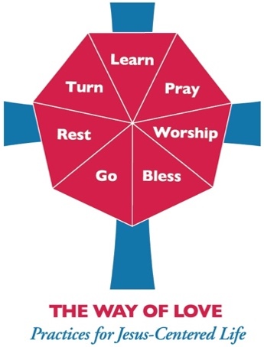
Tuesday, December 1
LEARN
Read Luke 1:30. What are you afraid of that keeps you from saying “yes” to God?

Wednesday, December 2
PRAY
Set a timer for three minutes. Silently repeat this prayer – “Here I am, God” – until time is up.

Thursday, December 3
BLESS
The angel blessed Mary with the gift of presence. To whom can you give the gift of presence this week?

Friday, December 4
TURN
In giving generously, St. Nicholas turned from a sense of scarcity to a posture of abundance. What do you need to turn from in order to be generous of heart?

Saturday, December 5
REST
From what could you rest in order to receive renewed life? Find that rest today, and do it for as long as you are able.

For more Advent resources related to the Way of Love, visit episcopalchurch.org/wayoflove. There, you’ll find links to the full Advent curriculum Journeying the Way of Love, as well as Living the Way of Love in Community, a nine-session curriculum for use anytime.

Tuesday, December 1
LEARN
Read Luke 1:30. What are you afraid of that keeps you from saying “yes” to God?

Wednesday, December 2
PRAY
Set a timer for three minutes. Silently repeat this prayer – “Here I am, God” – until time is up.

Thursday, December 3
BLESS
The angel blessed Mary with the gift of presence. To whom can you give the gift of presence this week?

Friday, December 4
TURN
In giving generously, St. Nicholas turned from a sense of scarcity to a posture of abundance. What do you need to turn from in order to be generous of heart?

Saturday, December 5
REST
From what could you rest in order to receive renewed life? Find that rest today, and do it for as long as you are able.

For more Advent resources related to the Way of Love, visit episcopalchurch.org/wayoflove. There, you’ll find links to the full Advent curriculum Journeying the Way of Love, as well as Living the Way of Love in Community, a nine-session curriculum for use anytime.

