December 6, 2019 – Advent 2 (B)
Second Week of Advent:
Journeying with Family and Friends

As we continue our Advent walk, we invite you to see the Way of Love as a journey that can expand to include family and friends. Mary said “yes” to the call to birth Jesus, God’s Word, into the world and immediately went in haste to share her good news with her cousin, Elizabeth—a four-day journey into the Judean hills. Isn’t that what happens when we hear good news? We are driven to go and tell others. The Way of Love is good news that demands to be shared.

Sunday, December 6
WORSHIP
What part of gathering for worship fills your heart with hope?

Monday, December 7
GO
Read or watch your local news. Where is reconciliation needed? Pray for healing.

Tuesday, December 8
LEARN
Read Luke 1:45. Consider how your faith is a blessing. Share your faith story with a friend.

December 6, 2019 – Advent 2 (B)
Second Week of Advent:
Journeying with Family and Friends

As we continue our Advent walk, we invite you to see the Way of Love as a journey that can expand to include family and friends. Mary said “yes” to the call to birth Jesus, God’s Word, into the world and immediately went in haste to share her good news with her cousin, Elizabeth—a four-day journey into the Judean hills. Isn’t that what happens when we hear good news? We are driven to go and tell others. The Way of Love is good news that demands to be shared.

Sunday, December 6
WORSHIP
What part of gathering for worship fills your heart with hope?

Monday, December 7
GO
Read or watch your local news. Where is reconciliation needed? Pray for healing.

Tuesday, December 8
LEARN
Read Luke 1:45. Consider how your faith is a blessing. Share your faith story with a friend
Wednesday, December 9
PRAY
Offer a prayer of thanks for each person you encounter – both stranger and friend – silently or aloud.

Thursday, December 10
BLESS
Call or write a family member with whom you desire a closer relationship. Share with them how they are a blessing.

Friday, December 11
TURN
Reflect: Where have I fallen short this week? How can I make amends? Give thanks for the gift of fresh starts that we have through God’s grace.

Saturday, December 12
REST
Set aside 30 minutes to rest, pause, and breathe deeply with a friend or family member. Give thanks for the restorative power of love in relationship.

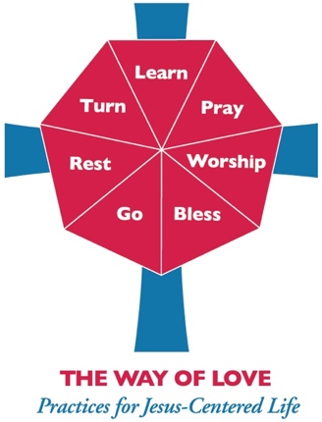
For more Advent resources related to the Way of Love, visit episcopalchurch.org/wayoflove. There, you’ll find links to the full Advent curriculum Journeying the Way of Love, as well as Living the Way of Love in Community, a nine-session curriculum for use anytime.

Wednesday, December 9
PRAY
Offer a prayer of thanks for each person you encounter – both stranger and friend – silently or aloud.

Thursday, December 10
BLESS
Call or write a family member with whom you desire a closer relationship. Share with them how they are a blessing.

Friday, December 11
TURN
Reflect: Where have I fallen short this week? How can I make amends? Give thanks for the gift of fresh starts that we have through God’s grace.

Saturday, December 12
REST
Set aside 30 minutes to rest, pause, and breathe deeply with a friend or family member. Give thanks for the restorative power of love in relationship.

For more Advent resources related to the Way of Love, visit episcopalchurch.org/wayoflove. There, you’ll find links to the full Advent curriculum Journeying the Way of Love, as well as Living the Way of Love in Community, a nine-session curriculum for use anytime.

