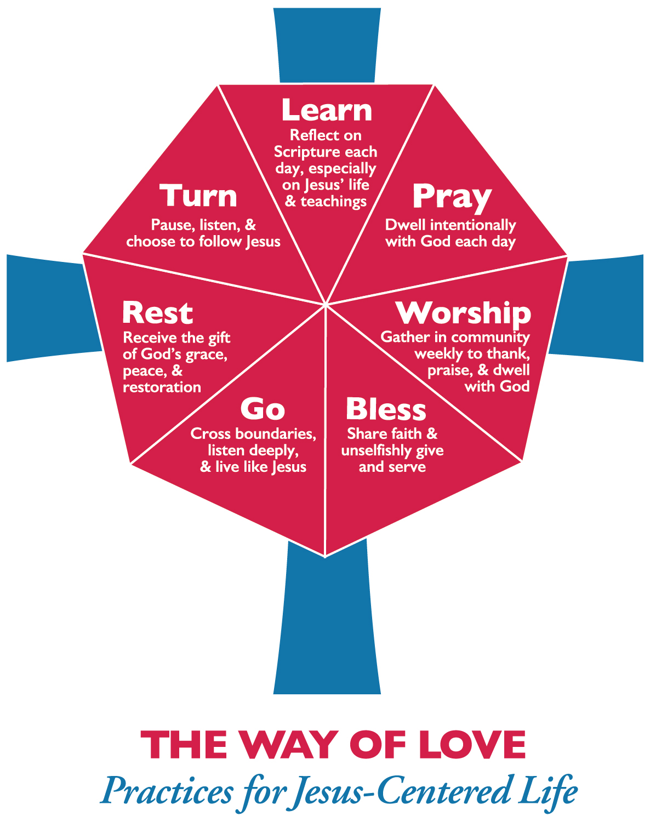
The Holy Scriptures
The Ten Commandments
Human Nature
Sin and Redemption
Holy Baptism
Prayer and Worship
The Holy Eucharist
The Christian Hope
The Creeds

God the Father
God the Son
The Holy Spirit
The Church
The Ministry
The Old Covenant
The New Covenant
The Sacraments
Other Sacramental Rites

Human Nature
God the Father
The Old Covenant
The Ten Commandments
Sin and Redemption
God the Son
The New Covenant
The Creeds
The Holy Spirit
The Holy Scriptures
The Church
The Ministry
Prayer and Worship
The Sacraments
Holy Baptism
The Holy Eucharist
Other Sacramental Rites
The Christian Hope

Session One: Overview
- Gather and open with a prayer
- Intros: Name, Grade/Age, Random Question like What kind of toothpaste do you use?
- Why are we here?
  - To be part of the Jesus Movement as The Episcopal Church.
  - Watch PB Curry video: https://www.episcopalchurch.org/jesus-movement
    - Reflection
  - To be prepared for Confirmation (for some)
    - Briefly describe what Confirmation is.
      - “Confirmation is the rite in which we express a mature commitment to Christ, and receive strength from the Holy Spirit through prayer and the laying on of hands by a bishop.” p. 860
- How do we do that? Way of Love and Catechism
  - Way of Love = Seven Steps for Jesus-Centered Living from PB Curry
    - Hand out "what do you seek?" cards with Way of Love
  - Catechism = An Outline of Faith in the BCP, Q&A format
    - Show that it's in the BCP
  - Why both? Categories of the Catechism line up with WofL = Road map for year.
- Watch Way of Love Intro Video
  - https://www.episcopalchurch.org/explore-way-love (Main video)
  - Reflection
- Hand out Worksheets
  - Here's how the Catechism lines up with WofL. Backside for notes as we go.
  - (Collect after each session so they don't lose or forget them for next time.)
- Final Thoughts, Collect sheets, Closing Prayer

Session Two: Turn
- Gather and open with a prayer
- Opening Question: What do you do when you realize you’re going the wrong way? TURN!
- Recap last session: Way of Love and Catechism together as Jesus Movement people
- Step One = Turn
  - Pause, listen, & choose to follow Jesus;
  - Human Nature, Sin and Redemption, Holy Baptism
- Read Human Nature in the Catechism p. 845
  - “We are part of God’s creation, made in the image of God.”
  - Watch Bible Project’s “Image of God” video:
https://www.youtube.com/watch?v=YbipxLDtY8c
- Read Sin and Redemption in the Catechism p. 848
  - “Sin is the seeking of our own will instead of the will of God, thus distorting our relationship with God, with other people, and with all creation.”
  - Watch Bible Project’s “Word Study: Khata - Sin” video:
https://www.youtube.com/watch?v=aNOZ7ocLD74
- Read Holy Baptism in the Catechism p. 858
  - The first step in our Turning to Jesus is Baptism.
  - New Life in Christ
  - Baptismal Covenant p.304
    - Creed and Questions
    - Note that we have the Creed in “Rest,” in that, we can Rest in them as statements of faith we say with others and when we need to Turn again, they are a place to start, as well as the Bap. Cov. questions. More on that with “Rest” step.
- Connections:
  - How does this fit with Turn: Pause, listen, and choose to follow Jesus?
  - What does all this mean for your daily life?
- Final Thoughts, Collect Sheets, Closing Prayer
Session Three: Learn
- Gather and open with a prayer
- Welcome Question: What did you LEARN this week?
- Learn: Reflect on Scripture each day, especially on Jesus’ life and teachings
  - The Holy Scriptures
    - Read the Catechism, p. 853
    - Watch: “What is the Bible?” by The Bible Project: https://www.youtube.com/watch?v=ak06MSETeo4
    - Watch: “The Story of the Bible” by The Bible Project: https://www.youtube.com/watch?v=7_CGP-12AE0
  - The Ten Commandments
    - Read the Catechism, p. 847
    - Watch: “The Law” by The Bible Project: https://www.youtube.com/watch?v=3BGO9Mmd_cU
- Practice!
  - Read Mark 7:1-23
  - How does Jesus interpret the Law? (He cares more about the heart of the Law and the heart of the person!)
- Conclusion
  - Tools for scripture reading and reflection
    - Just read it! Start with the Gospels, also check out the Psalms
    - The Bible Project on YouTube has some great videos
    - D365 Daily Prayer App
    - BibleGateway Bible App (with audio versions!)

Session Four: Pray
- Gather and open with a prayer
- Welcome Question: Anyone have a family Christmas tradition they’d like to share?
- Pray: Dwell intentionally with God each day
  - Prayer and Worship
    - Read the Catechism p. 856
    - “What is corporate worship?” HOLD THAT THOUGHT
    - First, let’s watch the “Shema” Bible Project video: https://www.youtube.com/watch?v=6KQLOuIKaRA
      - LISTEN and DO
  - The Holy Eucharist
    - Now, Holy Eucharist is our main form of corporate worship. Involves both Listening and Doing.
    - Read the Catechism p. 859
    - Don’t need a video, we’re going to church soon!
    - How does the Holy Eucharist relate to “Pray”
      - Look at Four Eucharistic PRAYERS
      - It is hearing AND responding (Shema-ing) to God
- Conclusion
  - Back to prayer - what are some different ways to pray?
    - Daily Office
    - Centering Prayer/Meditation
    - BCP prayers in back
    - “Pray-as-you-Go” Daily Podcast
    - “Pray without ceasing” = awareness of God in everyday life
    - “Make Work Worship” = saying integrating work with prayer/devotion to God

Session Five: Worship
- Gather and open with a prayer
- Welcome Question: Who’s going to win the Super Bowl?!
- Worship: Gather in community weekly to thank, praise, and dwell with God.
  - How?
    - Eucharist, singing, prayer, thanksgiving, etc.
  - Who?
    - That’s the key! We all worship something. Our call is to worship God alone.
- Who is God?
  - God is Trinity: Father, Son, and Holy Spirit. Three in one. Triune.
    - How does that work? Let’s watch The Bible Project’s “God” video (https://www.youtube.com/watch?v=eAvYmE2YYIU)
      - Read: God the Father p. 846
    - Okay. What about the Son?
      - Read God the Son p. 849
      - Let’s watch The Bible Project’s “The Messiah” video (https://www.youtube.com/watch?v=3dEh25pduQ8)
    - So, then what does that make the Holy Spirit?
      - Read The Holy Spirit p. 852
      - Watch The Bible Project’s “Holy Spirit” video (https://www.youtube.com/watch?v=oNNZO9i1Gjc)
- Why Worship?
  - Because it helps us recognize that we are not God but God is God.
  - Let Go and Let God.
- Concluding prayer

Session Six: Bless
- Gather and open with a prayer
- Welcome Question: What do you say when someone sneezes? Why might we say that? What does it mean to “Bless”?
- “Bless: Share faith and unselfishly give and serve”
  - We bless because God has blessed us. God shares God’s faith and unselfishly gives and serves the world through covenants.
- The Old and New Covenants
  - Read The Old Covenant in the Catechism p. 846
  - Read The New Covenant in the Catechism p. 850
  - Watch The Bible Project’s “Covenants” video: https://www.youtube.com/watch?v=8ferLIsvlmI
- The Sacraments and Other Sacramental Rites
  - In other words, God’s Covenants are ways we experience God’s Grace. The Sacraments and Other Sacramental Rites are ways we signify and engage with God’s grace as the Church.
  - Read The Sacraments p. 857
  - Read Other Sacramental Rites p. 860
  - Watch “Sacraments” video: https://www.youtube.com/watch?v=lOMie2kekLo
- Confirmation as a Sacramental Rite
  - BCP p. 412: Rubric! “public affirmation of their faith and commitment to the responsibilities of their Baptism and to receive the laying on of hands by the bishop.”
  - BCP p. 415: Presentation and Examination. THIS is what they’ll be doing. Go thru it.
- Closing Prayer #47 For Young Persons, p. 829 in the BCP

Session Seven: Go
- Gather and open with a prayer
- Welcome Question: If you could go anywhere in the world, where would you go?
- “Go: Cross boundaries, listen deeply, and live like Jesus”
  - … live like Jesus. That’s what this whole thing is all about! But what does that look like and who carries it out?
    - Living like Jesus = The Way of LOVE
    - The Church carries that out with its Ministry
- First, LOVE
  - What is LOVE? (Baby don’t hurt me.) Watch The Bible Project’s “Agape” video: https://www.youtube.com/watch?v=slyevQ1LW7A
  - Great recap of The Way of Love: Practices for Jesus Centered Life. Go = taking all that we know about LOVE and sharing it with others.
- Next, who does LOVE? The Church through its Ministry.
  - Read The Church and The Ministry in the Catechism, p. 854-856.
  - Mission = “to restore all people to unity with God and each other in Christ” i.e. to help the world Love God and Love Neighbor.
  - We ALL have a part to play in this ministry.
- What does THAT look like?
  - What ministries does your church do that show Jesus’ love?
  - Check out what this church is doing: https://www.episcopalchurch.org/library/video/grace-go-church-heavenly-rest
  - And how does Confirmation fit into that? https://www.episcopalchurch.org/library/video/confirmation-year-episcopal-life
- Wrap up: “Go” = the dismissal at church.
  - BCP p. 366 for different dismissals.
  - Also, the phrase, “Our worship is over. Our service begins.”
  - AMEN!

Session Eight: Rest
- Gather and open with a prayer
- Welcome Question: When was the last time you were able to really rest?
- Rest: Receive the gift of God’s grace, peace, and restoration.
  - Grace = “one-way love”; love that comes from God and doesn’t depend on us.
  - Peace = the knowledge that we are loved by God no matter what and that we don’t have to be afraid of anything because God is with us.
  - Restoration = because of this grace and peace, we can have right relationships with God, our neighbors, and ourselves. And we can take time to REST because we know God has “got this” and we can let go.
    - That global restoration is already but not yet and so we have The Christian Hope
- The Christian Hope
  - Read the Catechism p.861
  - Watch the Bible Project’s “Hope” Word Study https://www.youtube.com/watch?v=4WYNBjJSYvE
- The Creeds
  - The Creeds are not hoops to jump through, they are green pastures to rest in. (Ps. 23)
  - Rest in a Creed? Yes, because when we say the Creed together as a church, we support each other in our shared belief even if, individually, we may have doubts about pieces of a Creed.
  - Read Catechism p. 851
    - “I/We Believe” What does it mean to believe?
      - Less intellectual assent, more trust and love. “Be-love.”
      - You can love God without understanding everything about God (which we can never truly do, by the way).
  - Watch “The Creed” https://www.youtube.com/watch?v=0YNeTwWU1RE
  - Pray it. Love it. Live it. — The Way of Love.
- Close with the original video of PB Curry on The Way of Love: https://www.episcopalchurch.org/jesus-movement
  - Turn, Learn, Pray, Worship, Bless, Go, Rest… and have fun!

