April 25, 2021 – Easter 4 (B)
The Episcopal Church Racial Justice Audit

After two years and more than 1,300 surveys, the ground-breaking Racial Justice Audit of Episcopal Leadership (iam.ec/rja) is now available to the wider church and public. The audit identifies nine “patterns” of systemic racism – ranging from the historical context of church leadership to current power dynamics — that will also be highlighted in three public webinars in May and June.

Conducted by the Mission Institute in partnership with The Episcopal Church’s Racial Reconciliation and Justice Team, the audit focused on two key questions: who makes up the leadership of the church; and what are their experiences of race and racism in their leadership roles? The Mission Institute team mined the data for key insights about race and power and offered long-term recommendations.

“This racial justice audit, I think for the first time, has given us a real picture of the dynamics and the reality of structural and institutional racism among us,” Episcopal Church Presiding Bishop Michael Curry said. “It has given us a baseline of where we are, to help us understand where we can, and must, by God’s grace, go.”

The survey was sent to nearly 3,000 clergy and lay leaders, with a response completion rate of 45 percent, or 1,326. Research focused on the church’s major leadership bodies: the House of Bishops, House of Deputies, Executive Council, Episcopal Church

April 25, 2021 – Easter 4 (B)
The Episcopal Church Racial Justice Audit

After two years and more than 1,300 surveys, the ground-breaking Racial Justice Audit of Episcopal Leadership (iam.ec/rja) is now available to the wider church and public. The audit identifies nine “patterns” of systemic racism – ranging from the historical context of church leadership to current power dynamics — that will also be highlighted in three public webinars in May and June.

Conducted by the Mission Institute in partnership with The Episcopal Church’s Racial Reconciliation and Justice Team, the audit focused on two key questions: who makes up the leadership of the church; and what are their experiences of race and racism in their leadership roles? The Mission Institute team mined the data for key insights about race and power and offered long-term recommendations.

“This racial justice audit, I think for the first time, has given us a real picture of the dynamics and the reality of structural and institutional racism among us,” Episcopal Church Presiding Bishop Michael Curry said. “It has given us a baseline of where we are, to help us understand where we can, and must, by God’s grace, go.”

The survey was sent to nearly 3,000 clergy and lay leaders, with a response completion rate of 45 percent, or 1,326. Research focused on the church’s major leadership bodies: the House of Bishops, House of Deputies, Executive Council, Episcopal Church

Center/churchwide staff; and a representative sample of diocesan leaders from 28 of the 109 dioceses of The Episcopal Church.
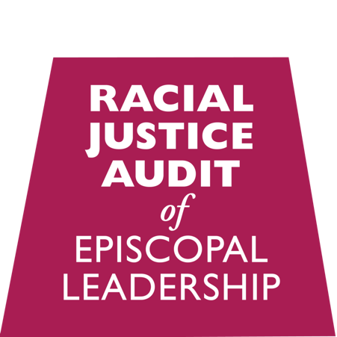
Survey respondents were invited to participate in more in-depth narrative interviews designed to surface personal stories and reflections on race and racism across the church. The Mission Institute team conducted approximately 65 interviews, in person and via Zoom after the onset of COVID-19.

The Rev. Gay Jennings said the audit has already been helpful to the House of Deputies, of which she is president. The House of Deputies comprises equal numbers of clergy and laypeople, all of whom are elected to the governing body. “This audit of church leadership, which represents the work of many people over several years, provides us with invaluable data that will help us draw closer to the Beloved Community that we long to be,” she said. “We are already taking action based on its findings, and we look forward to continuing this essential work.”

The audit rose in response to resolutions at The Episcopal Church’s 78th General Convention in 2015 and as part of the church’s long-term commitment to Becoming Beloved Community. The resolutions to Work for Racial Justice and Reconciliation and to Address Systemic Racial Injustice formally acknowledged and repented of The Episcopal Church’s “historic and contemporary participation in this evil” and urged the Executive Council to conduct an internal audit to assess racial disparity and systemic injustices within the church.

Learn more about the webinars and audit and find supporting materials at the bilingual website: iam.ec/rja.

Center/churchwide staff; and a representative sample of diocesan leaders from 28 of the 109 dioceses of The Episcopal Church.
Survey respondents were invited to participate in more in-depth narrative interviews designed to surface personal stories and reflections on race and racism across the church. The Mission Institute team conducted approximately 65 interviews, in person and via Zoom after the onset of COVID-19.

The Rev. Gay Jennings said the audit has already been helpful to the House of Deputies, of which she is president. The House of Deputies comprises equal numbers of clergy and laypeople, all of whom are elected to the governing body. “This audit of church leadership, which represents the work of many people over several years, provides us with invaluable data that will help us draw closer to the Beloved Community that we long to be,” she said. “We are already taking action based on its findings, and we look forward to continuing this essential work.”

The audit rose in response to resolutions at The Episcopal Church’s 78th General Convention in 2015 and as part of the church’s long-term commitment to Becoming Beloved Community. The resolutions to Work for Racial Justice and Reconciliation and to Address Systemic Racial Injustice formally acknowledged and repented of The Episcopal Church’s “historic and contemporary participation in this evil” and urged the Executive Council to conduct an internal audit to assess racial disparity and systemic injustices within the church.

Learn more about the webinars and audit and find supporting materials at the bilingual website: iam.ec/rja.

