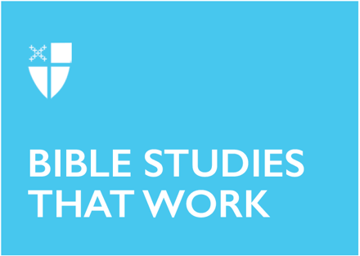

Pentecost 2
Proper 5 (B)
June 6, 2021

RCL: 1 Samuel 8:4-11, (12-15), 16-20, (11:14-15); Psalm 138; 2 Corinthians 4:13-5:1; Mark 3:20-35

1 Samuel 8:4-11, (12-15), 16-20, (11:14-15)
The people are clamoring, demanding a king. They have been burnt by the rule of judges; Joel and Abijah, Samuel’s sons, are corrupt and have accepted bribes.

The Israelites want to “keep up with the Joneses.” They see all the nations around them with kings, so why can’t they have a king, too? Everyone else is doing it!

The rule of a king or judge may not be inherently bad, but the rejection of God’s authority and providence displeases God. Samuel prophesies, warning the people that God will not listen to them on the day when they realize they made a mistake and cry to God.

- Think of times of transition when you had to discern God’s will.
- How are you affected by the lives of those around you?

Psalm 138
In today’s psalm, there are multiple echoes of Biblical themes and language found in some of the most well-known passages of the Bible. Verse 7 echoes in part the Magnificat: God cares for the lowly. Verse 8 sounds a lot like part of Psalm 23: God keeps us safe, even though we walk through darkness. Verse 9 follows the repeated refrain of Psalm 136: God’s love endures forever. Yet, this all comes after David’s personal praise of God. He moves from personal praise to universal praise.

- Can you think of a time when your personal thanksgiving and praise moved you to a deeper or higher moment of universal praise of God?

2 Corinthians 4:13-5:1
“Our inner nature is being renewed day by day,” Paul says. Renewal takes many different shapes and forms. Renewal can come with expectation or it can take us by surprise. Sometimes, we experience renewal with fanfare and fireworks; sometimes, we only see renewal in the rear-view mirror.

Paul, in his letter to the Romans, also says that inner renewal is what helps us discern the will of God, what is good and perfect and acceptable. We may switch up our surroundings or alter our outward appearances, but those changes are not actually renewal and do not help us discern the will of God.

- On a day-to-day basis, how do you experience renewal?
- Think of a time when renewal of your inner nature has led you to discernment of God’s will in your life.

Mark 3:20-35
In this passage from Mark, Jesus continues his challenges against the scribes, some of the religious leaders of the day. He tells the crowd that those who do the will of God are his brothers and sisters and mothers, creating a new kind of community of God, one that resembles the close-knit relationships of siblings and parents, closer than mere friends or neighbors or colleagues.

What follows in Mark are several parables about the Kingdom of God. The parables are difficult for many to understand, but Jesus assures his disciples that he has revealed to them secrets of the Kingdom of God. However, Jesus did not reveal the mystery of the Kingdom of God to only the apostles; immediately prior to today’s passage, Jesus called his disciples with the express intention of proclaiming the message.

- What brothers, sisters, siblings, mothers do you see around you doing the will of God?
- How can you help build this new kind of community?

This Bible study was written by Joseph Cundiff, a seminarian at Berkeley Divinity School at Yale.

