May 9, 2021 – Easter 6 (B)
Support the Annual Appeal
Last November at the Holding onto Hope service at the National Cathedral, I preached that the mountain in Matthew, chapter 5, was not incidental to the story. Jesus went to and spoke from the Mount so that folks could see the Promised Land. He pointed us in the direction of God’s promise and asked us to be bold in following him.
How do we follow Him? Through prayer, study, and fellowship. Among our Baptismal promises, we vow to “… continue in the apostle’s teaching and fellowship in the breaking of the bread and in the prayers.” Each day in parishes and dioceses, friends, neighbors, and fellow Christians gather remotely, to pray and to study, often using resources developed by the ministries of The Episcopal Church. Consider these, for example.
Living the Way of Love Small Group Curriculum
More than a program or curriculum, this is an intentional commitment to a set of practices. It’s a commitment to follow Jesus in these ways: Turn, Learn, Pray, Worship, Bless, Go, Rest.
Sacred Ground: A Film-Based Dialogue Series on Race and Faith
This series holds the vision of a beloved community as a guiding star, where all people are honored, protected, and nurtured as beloved children of God who weep at one another’s pain and seek one another’s flourishing.
Make Me an Instrument of Peace: A Guide to Civil Discourse
This interactive, five-part curriculum introduces the tools of civil discourse to enable new ways to love our neighbor.
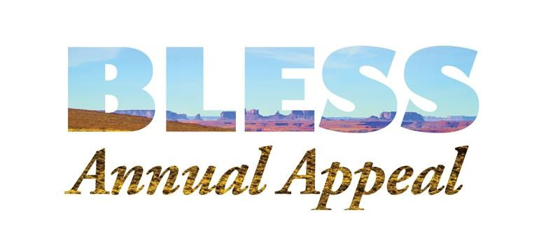
Each of these programs and courses seeks to draw searchers and faithful to the Mount, with Jesus, and show the way to the Promised Land. Your gift to the Bless Annual Appeal supports the development of new resources and amplifies our voice in praising Jesus. Will you join us and make a gift to the Bless Annual Appeal?
To make your gift, you can:
- Give online: iam.ec/blessgiving
- Call: (800) 334-7626 ext. 6002
Please join us on the Mount and on the march to the Promised Land!
Your brother in Christ,
Michael B. Curry

