July 4, 2021 – Pentecost 6 (B)
Independence Day

On July 4th, The Episcopal Church joins the United States in celebrating Independence Day, marking the day the country declared independence from the Kingdom of Great Britain in 1776.

Collect for Independence Day
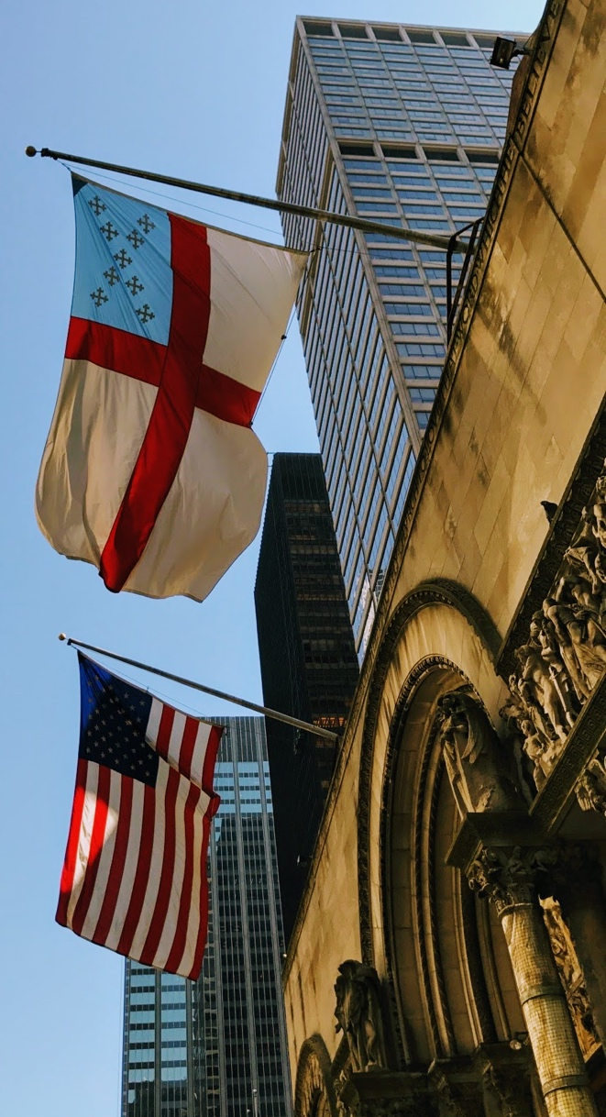
Lord God Almighty, in whose Name the founders of this country won liberty for themselves and for us, and lit the torch of freedom for nations then unborn: Grant that we and all the people of this land may have grace to maintain our liberties in righteousness and peace; through Jesus Christ our Lord, who lives and reigns with you and the Holy Spirit, one God, for ever and ever. Amen.

Book of Common Prayer, p. 242

Collect 17: For the Nation

Lord God Almighty, you have made all the peoples of the earth for your glory, to serve you in freedom and in peace: Give to the people of our country a zeal for justice and the strength of forbearance, that we may use our liberty in accordance with your gracious will; through Jesus Christ our Lord, who lives and reigns with you and the Holy Spirit, one God, for ever and ever. Amen.

Book of Common Prayer, p. 258

