July 11, 2021 – Pentecost 7 (B)

The Feast of Nathan Söderblom

Swedish bishop Nathan Söderblom was the first member of the clergy to receive the Nobel Peace Prize. Born Lars Olof Jonathan Söderblom, on January 15, he graduated from Uppsala University in 1883 and was ordained a priest in the Church of Sweden (Lutheran) in 1893. He earned his doctorate in theology at the Sorbonne and taught theology at the University of Uppsala until his appointment as Archbishop of Uppsala in 1914.

During the First World War, Archbishop Söderblom called on Christian leaders to work for peace and justice. He believed that all Christian church communities were called to fight unhealthy nationalism, racism, militarism and the oppression of minorities. At the same time, he proposed that Jesus' message of love disseminated from pulpits, in newspapers, and in schools to create a powerful body of Christian opinion across national borders in favor of peace.

He famously wrote in his work, The Content of Christian Faith:

“For me everything is absorbed by the one big question – the question of reconciliation and healing [restoration.] Do we see God’s way in the terrible chaos of this world; the way which for the human reason is a source of offense, but remains the only

July 11, 2021 – Pentecost 7 (B)

The Feast of Nathan Söderblom

Swedish bishop Nathan Söderblom was the first member of the clergy to receive the Nobel Peace Prize. Born Lars Olof Jonathan Söderblom, on January 15, he graduated from Uppsala University in 1883 and was ordained a priest in the Church of Sweden (Lutheran) in 1893. He earned his doctorate in theology at the Sorbonne and taught theology at the University of Uppsala until his appointment as Archbishop of Uppsala in 1914.

During the First World War, Archbishop Söderblom called on Christian leaders to work for peace and justice. He believed that all Christian church communities were called to fight unhealthy nationalism, racism, militarism and the oppression of minorities. At the same time, he proposed that Jesus' message of love disseminated from pulpits, in newspapers, and in schools to create a powerful body of Christian opinion across national borders in favor of peace.

He famously wrote in his work, The Content of Christian Faith:

“For me everything is absorbed by the one big question – the question of reconciliation and healing [restoration.] Do we see God’s way in the terrible chaos of this world; the way which for the human reason is a source of offense, but remains the only

possible way? This way does not avoid the tragedy of human life but goes through the very middle of it.”

Archbishop Söderblom took great interest in the early liturgical renewal movement among Roman Catholics, Anglicans and Lutherans. He saw a profound connection between liturgical worship, personal prayer, and social justice. In 1925 he invited Anglican, Reformed, Lutheran, and Orthodox leaders to Stockholm and together they formed the Universal Christian Council on Life and Work. His ecumenical work led eventually to the formation of the World Council of Churches in 1948.

Söderblom’s advocacy for Church unity as a means toward to accomplishing world peace earned him the Nobel Peace Prize in 1930. After his death in Uppsala, Sweden, in 1931 his body was interred in Uppsala Cathedral. He is commemorated in the liturgical calendar of The Episcopal Church on July 12.

Collect for the Feast of Nathan Söderblom

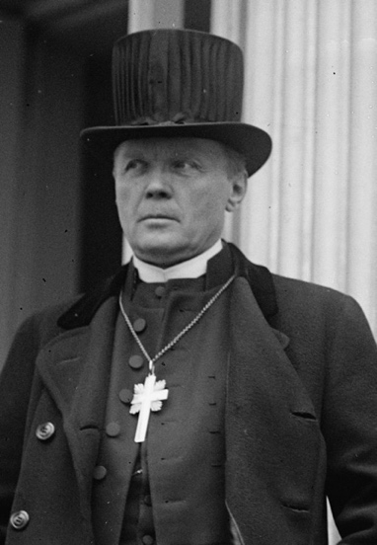
Almighty God, we bless your Name for the life and work of Nathan Söderblom, Archbishop of Uppsala, who helped to inspire the modern liturgical revival and worked tirelessly for cooperation among Christians. Inspire us by his example, that we may ever strive for the renewal of your Church in life and worship, for the glory of your Name; who with Jesus Christ and the Holy Spirit lives and reigns, one God, for ever and ever. Amen.
possible way? This way does not avoid the tragedy of human life but goes through the very middle of it.”

Archbishop Söderblom took great interest in the early liturgical renewal movement among Roman Catholics, Anglicans and Lutherans. He saw a profound connection between liturgical worship, personal prayer, and social justice. In 1925 he invited Anglican, Reformed, Lutheran, and Orthodox leaders to Stockholm and together they formed the Universal Christian Council on Life and Work. His ecumenical work led eventually to the formation of the World Council of Churches in 1948.

Söderblom’s advocacy for Church unity as a means toward to accomplishing world peace earned him the Nobel Peace Prize in 1930. After his death in Uppsala, Sweden, in 1931 his body was interred in Uppsala Cathedral. He is commemorated in the liturgical calendar of The Episcopal Church on July 12.

Collect for the Feast of Nathan Söderblom

Almighty God, we bless your Name for the life and work of Nathan Söderblom, Archbishop of Uppsala, who helped to inspire the modern liturgical revival and worked tirelessly for cooperation among Christians. Inspire us by his example, that we may ever strive for the renewal of your Church in life and worship, for the glory of your Name; who with Jesus Christ and the Holy Spirit lives and reigns, one God, for ever and ever. Amen.

