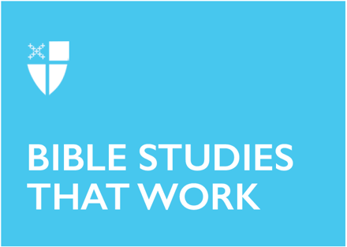

Pentecost 18
Proper 21 (B)
September 26, 2021

RCL: Esther 7:1-6, 9-10; 9:20-22; Psalm 124; James 5:13-20; Mark 9:38-50

Esther 7:1-6, 9-10; 9:20-22
Esther is perhaps the most fun of all the biblical books! A hilarious cast of characters, comedic turns of fate, and a clear commendation of enjoyment make this story a delight! And, of course, the story of Esther animates the wonderful Jewish holiday known as Purim. It is remembered on this day how Queen Esther and her cousin Mordecai saved the Jewish people of Persia from the plots of the wicked Haman. Purim includes costumes and noisemakers which are sounded whenever the name “Haman” is mentioned in the text! Another Purim tradition derived from the ancient Babylonian Talmud is that Jews are to drink until they cannot tell the difference between the phrases “cursed be Haman” and “blessed be Mordecai!”

While the book of Esther conveys much wisdom and is a joy to recite, let’s focus on two brief points. First, the book does not mention God. Rather, we intuit that God is at work in events and in the characters’ choices and intuitions. Isn’t it much the same for us? Like Esther and Mordecai, we are called to discern and act in our circumstances as best we can. The invitation is to trust that God is mysteriously, quietly at work beneath the surface. What’s more, our reading concludes with a call to celebrate and enjoy! We don’t often hear such an enjoinder under the auspices of religion. Our ancestors in faith understood that life is above all a gift to be celebrated and enjoyed; that there indeed should be days of “feasting and gladness”!
- How can we make days of “feasting and gladness” a spiritual practice, as commended by the book of Esther?

Psalm 124
Our psalm verses this week strike themes of new life, redemption, and the trustworthiness of the Lord. Verse 8 expresses a truth that is key to the Christian journey – “Our help is in the name of the Lord.” In other words, we can’t do it on our own. Our ultimate security, peace, meaning, and future require our cooperation with God’s transformative grace. Though we value “independence” and have internalized the non-biblical teaching that “God helps those who help themselves”, Psalm 124 stands as a counter-witness to this kind of thinking. The authors of this poem lived through a trial that threatened their very survival (perhaps the Babylonian Exile). They teach us that in the experience of having nowhere else to turn but God, one is initiated into the reality of human limits and vulnerability, and also the power of God to deliver from the flood that would have swept us away (v. 4).
- How have you experienced the truth that “Our help is in the name of the Lord?”

James 5:13-20
James emphasizes the importance of rituals in the life of faith. The instruction to call for the elders to pray over the sick, using oil in the name of the Lord, has been interpreted in our tradition as a forerunner of the sacrament of anointing. Similarly, the teaching that we should confess our sins to one another is held as a prototype of sacramental confession. James recognizes the need for human contact through ritualized gestures. These speak in a powerful way to the human heart.

James concludes by underscoring his major theme – faith in action. Christians are called to hear the word and put it into practice. Faith in action is faith that works for the building up and preservation of the community. Although individual members of a community might be sinners, the good work to maintain the unity of the group serves to counteract, to “cover a multitude of sins” (v. 20).
- How have ritual gestures and prayers been important to your experience of Christian faith?

Mark 9:38-50
The metaphor of the body was a commonly used teaching tool in the ancient world, and we see Jesus take it up in our verses this week. While often used to symbolize the community (see also 1 Cor. 12), Jesus creatively uses “body” to address the matter of scandal. We might find Jesus’ language harsh, for he says in effect if a member of the community is leading others astray, that member should be removed, before the whole body is damaged. And his concluding proverb about salt is not innocuous. Salt was used in the ancient Near East as a catalyst to start fires. He is telling his audience to be confrontational at times. Verse 50 could be interpreted to mean that troublemakers should be confronted so that the community can have peace. This passage, when read in this light, is among the “hard sayings” of Jesus. In the context of our modern church communities, we are invited to carry the tension between protecting the integrity of the community and being compassionate toward the wayward.
- How might we go about discerning when scandal is a danger to the community, and how we might confront it?

Brian B. Pinter is a teacher of religious studies at Fordham Preparatory School in the Bronx and a Pastoral Associate at the Church of St. Ignatius Loyola in Manhattan.

