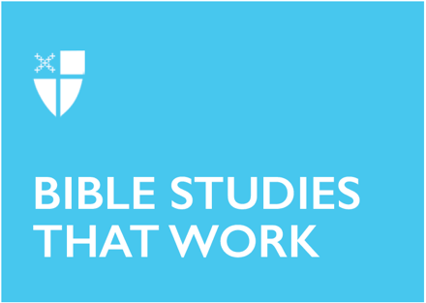

All Saints’ Day (B)
tr. November 7, 2021

RCL: Wisdom of Solomon 3:1-9 or Isaiah 25:6-9; Psalm 24; Revelation 21:1-6a; John 11:32-44

Wisdom 3:1-9
This passage from Wisdom is read on All Saints Day and at many funerals because it gives comfort to those who have experienced the death of a loved one. When we watch someone suffer and die it seems like disaster, destruction, or maybe even punishment. But the writer draws us up to a higher plain where we can see that their departure is a pathway to peace and great good.

The gift of All Saints Day is not simply to look back with nostalgia but to see a greater vision. Our loved ones who have died connect us to an eternal reality. By lifting our gaze to see them from God’s view we are given a “hope full of immortality.”

The great hope of this passage is God himself. It tells us that “the faithful will abide with him in love.” God is the ultimate reality. In God, instead of torment and death, there is grace, mercy, peace, and love.
- How does this passage give you comfort as you think about those you have lost?
- What is it like for you to imagine a place with no torment and only peace?

Psalm 24
Psalm 24 is a beautiful picture describing the two-way movement in our relationship with God. The psalmist first grounds our relationship to this earth, where we are part of all God’s creation.

From this vantage point we are called to make our way up to the Lord. If we want to see God, how we live matters. Clean hands and a pure heart are required. I often soil my hands and heart, so this is troubling. As we seek God we come to understand that we are made clean through God’s salvation and thus can continue to move toward God.

The end of the psalm reverses this movement. Now instead of us going up to God, God comes down to us. As God’s people we are summoned to look up and see that our strong and mighty God is coming down to be with us. Through this psalm we see a dance in which we move to God and God moves to us.
- What steps do you need to take in your movement toward God?
- How can we, God’s people, open up our gates to welcome God?

Revelation 21:1-6a
Stories have a beginning, a middle, and an end. One of the great gifts of the incarnation is that the one who calls himself the alpha and the omega, the beginning and the end, also understands the middle where we all live. For us mortals “the middle” includes mourning, crying, and pain. In the midst of the middle it takes great imagination to behold the possibility of a happy ending.

The people suffering under the cruel occupation of the Roman Empire were given an invitation through John’s Revelation to imagine a new world – a world where God lives with mortals and tenderly wipes every tear from their eyes.
- If this is the end of your story, how can you write your present “middle chapters” in light of it?
- What choices can you make to help you get there?

John 11:32–44
Jesus sees the big picture. He was able to live within the tension of the realities of death and a future resurrection. He knows Lazarus will live again. But when he sees his friends’ pain caused by their brother’s death, Jesus’ indignation drives him to both tears and action. Jesus shows how angry death makes him, how deeply he grieves for those who are hurt by it.

Isn’t this how we sometimes feel about death? Don’t our hearts break when death steals away those we love? We can proclaim “I believe in … the resurrection of the body, and life everlasting” (BCP, p 304) even while we are shattered with grief. This day on which we celebrate all the saints who have died can be a bitter reminder of all we have lost. Fortunately we have a God who will live with us in this place between death and life.
- What is it like for you to have a God who is the resurrection and the life and who also truly empathizes with your sorrow?
- How can being honest with God about your feelings help you walk through your grief?

This Bible study, written by Louise Samuelson, originally ran for All Saints’ Day in 2015.

