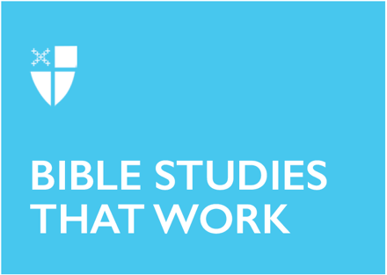

Pentecost 23
Proper 26 (B)
October 31, 2021

RCL: Ruth 1:1-18; Psalm 146; Hebrews 9:11-14; Mark 12:28-34

Ruth 1:1-18
Naomi finds herself in a foreign land without any means of support. Her husband and two sons have died. At that time in history this situation meant a future of abject poverty and humiliation. The only hope for her daughters-in-law is to find new husbands. Naomi’s only hope is to return to her home in Judah. In Judah the LORD was providing food for his people. The tradition then was that a childless widow should marry her deceased husband’s brother. Naomi has no more sons. This is why she blesses her daughters-in-law and tells them to stay in Moab to be with their people and gods, and to find new husbands.

Orpah agrees in tears. Ruth however will not go. The writer of the book of Ruth gives us a beautiful song that expresses Ruth’s devotion to Naomi. She will not only accompany Naomi, she will be one of Naomi’s people and Yahweh will become her god. She submits herself to the LORD’s will.
- Has there been a time in your life that you found yourself in a “foreign land” with no support?
- Do you find hope in the thought that God considers you and will provide?
- Is there someone in your life who is in the “foreign land” of illness, unemployment, or some other insecurity? Can you be a Ruth for them and share in the hopeful journey back to God’s grace?

Psalm 146
This is certainly a praise filled Psalm. The writer’s joy is spilling over. Doesn’t the section about all that the LORD does setting prisoners free, opening the eyes of the blind, etc. sound like the instructions Jesus gives to the disciples when he sends them out to do the work he commands them to do? Jesus empowers them to do the same things he has been doing. We, too, are called to do this work as we live into our baptismal covenant.
- You may not feel you have enough faith to literally give sight to the blind, but can you show someone how your eyes have been opened?
- What are some ways we in our church communities can watch over strangers?

Hebrews 9:11-14
In this epistle, the writer lays out the atonement understanding of Christ’s death. It is one that many of us in our modern world find hard to understand or accept. It probably made much more sense for the early followers of Jesus who struggled to understand why he was executed.

The tradition of animal sacrifice was well understood by the Israelites. In fact animal and even human sacrifice have been a part of many religions and cultures. There seems to be a universal mystical view of what we call a creature’s “life’s blood”. Further there is a sense that to kill an animal not to be used for food and shed its blood is a meaningful sacrifice. Many people have felt that this kind of sacrifice can restore our relationship with the creator.

First Testament texts call for the sacrificial animal to be perfect and of the greatest value, not one that is defective or ill. So for the early Christians it makes sense to see Christ as the perfect unblemished sacrifice. He was innocent and his death was a sacrifice on our behalf. Through it our relationship with God the Creator is restored. It is a hard teaching for us in our modern time but it is a powerful one we must consider.
- Do you find the atonement view a difficult one to accept?
- Is it hard to recognize that our sins are severe enough to need this kind of sacrifice from Jesus the Christ?
- If you have ever felt that what you have done is unforgivable can you find comfort in this understanding of Christ’s death?

Mark 12:28-34
This passage is quite remarkable in many ways. Two extraordinary things come to mind right away. The first is that usually in the Gospels the Scribes or Pharisees come to listen to Jesus in the hope of hearing him say something blasphemous. If they ask questions it is to try to trick him into saying something that can be held against him. In this case the Scribe is impressed with how Jesus has been answering the questions. Jesus is worth consulting. He assumes that among the long list of laws of what is permitted, what is prohibited, and how to carry out rituals, there is one that is most important.

The second extraordinary thing is how Jesus sums up the whole intent of all the laws, rituals, and traditions. He cuts to the heart of the matter and reveals the big picture at the same time. By sighting these two commandments, God is one and you shall love God with all your heart, soul, mind and strength, and love your neighbor as yourself, Jesus points us directly to how God wants us to live. The scribe understands that this is the key. Jesus affirms the scribe’s understanding by telling him that he is not far from the kingdom of God. The profundity of this leaves everyone speechless.
- Do you think that by affirming the scribe in this way, Jesus is showing us how to bring about the Kingdom of God on earth?
- Have you ever had an impulse to act in a certain way and done differently when you remember these two commandments?
- Can you imagine trying for one day to keep these commandments at the forefront of your mind? What would that be like for you?

This Bible study, written by Greg Hamlin, originally ran for Proper 26B in 2018.

