October 3, 2021 – Pentecost 19 (B)
The Feast of St. Francis of Assisi

On October 4, The Episcopal Church celebrates the feast day of Francis of Assisi, an Italian friar, beloved saint, and one of the most venerated individuals in Christian history. He founded the Franciscan Order for men and the Order of Saint Clare for women, and he is also widely known for his love of nature and animals. Perhaps the most famous prayer attributed to St. Francis is:
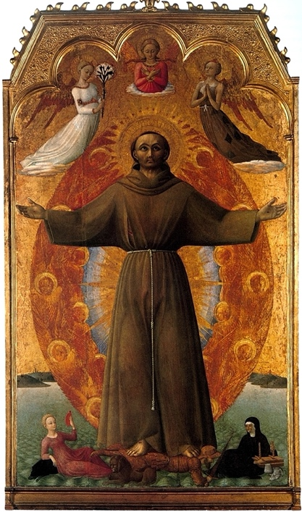
Lord, make us instruments of your peace.
where there is hatred, let us sow love;
where there is injury, pardon;
where there is discord, union;
where there is doubt, faith;
where there is despair, hope;
where there is darkness, light; and
where there is sadness, joy.
Grant that I may not so much seek to be consoled as to console;
to be understood as to understand;
to be loved as to love.
For it is in giving that we receive;
it is in pardoning that we are pardoned;
and it is in dying that we are born to eternal life. Amen.

But did you know St. Francis is also credited with these inspiring and challenging quotes?

- Start by doing what's necessary; then do what's possible; and suddenly you are doing the impossible.
- If you have men who will exclude any of God's creatures from the shelter of compassion and pity, you will have men who will deal likewise with their fellow men.
- While you are proclaiming peace with your lips, be careful to have it even more fully in your heart.
- All the darkness in the world cannot extinguish the light of a single candle.
- A single sunbeam is enough to drive away many shadows.

Collect for the Feast of St. Francis
Most high, omnipotent, good Lord, grant your people grace to renounce gladly the vanities of this world; that, following the way of blessed Francis, we may for love of you delight in your whole creation with perfectness of joy; through Jesus Christ our Lord, who lives and reigns with you and the Holy Spirit, one God, for ever and ever. Amen.

