November 28, 2021 – Advent 1 (C)
First Week of Advent: Saying “Yes” to the Journey

As Advent begins this week, we invite you to orient yourself to the coming of Jesus at Christmas through the practices of Journeying the Way of Love. This journey begins by saying “yes” to God’s call to birth new life into the world—a call that is both powerful and gentle, a call that will, if fully embraced, grow beyond our imaginations, spilling out of ourselves and into our family, friends, community, and the whole world. Over the course of this holy season, we invite you to respond to that call using these daily practices, and encourage you to offer them to your friends, family, and neighbors.

For more Advent resources related to the Way of Love, visit episcopalchurch.org/wayoflove. There, you’ll find links to the full Advent curriculum Journeying the Way of Love, as well as Living the Way of Love in Community, a nine-session curriculum for use anytime.

Sunday, November 28
WORSHIP
Read Luke 21:25-36. How do the symbols of the Advent season help you understand the story of Jesus? Where do you see them in your worship today?

Monday, November 29
GO
Go out of your way to have a conversation with someone you might not normally visit with today. Ask God to open your heart to hear this person as God does.

Tuesday, November 30
LEARN
Read Matthew 4:18-22. How do these verses from Matthew inspire you to read Scripture with new eyes? Try reading several different translations of this passage. See how the language might change your reading of it.

Wednesday, December 1
PRAY
Pray along with the Collect for Advent 1, found on page 211 of The Book of Common Prayer. Set a timer for three minutes to sit in silence and hear what God might be saying back to you.

Thursday, December 2
BLESS
We know that angels are God’s special messengers to us, and that Gabriel spent intentional time with Mary, helping her to understand her part in God’s story. Who has shared an important lesson or their presence with you this week? Thank them today with a call or note.

Friday, December 3
TURN
Read Isaiah 58. How does this reading challenge you to think about feasts and festivals differently? How might this lesson change the way you celebrate or recognize this holy season?
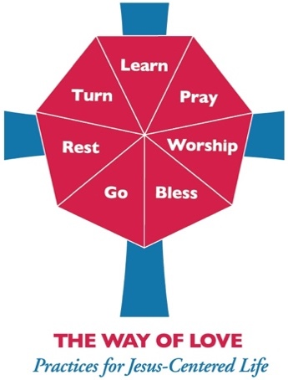
Saturday, December 4
REST
Put your phone on airplane mode and leave it in a dresser drawer for an hour or two. Whatever happens in that time, you can handle later. Give this time to yourself and Jesus, to rest and recharge for the week ahead.

