December 12, 2021 – Advent 3 (C)
Third Week of Advent: Journeying with Community

As we continue our Advent walk, we invite you to see the Way of Love as a journey that includes the community. The witness of Zechariah and Elizabeth who bring infant John to the Temple to be circumcised reminds us of the importance of our faith community to sustaining the Way of Love. Just as the community did for John’s family, communities provide a place for discernment, sometimes challenging us and other times affirming us. Communities celebrate and mark important moments along the journey. For more Advent resources related to the Way of Love, visit episcopalchurch.org/wayoflove. There, you’ll find links to the full Advent curriculum Journeying the Way of Love, as well as Living the Way of Love in Community, a nine-session curriculum for use anytime.

Sunday, December 12
WORSHIP
Imagine the faces you’d like to see at church — an all-star list of folks you want to worship with. This could be people you know from summer camp when you were a kid, people who might have already died, people you work with — all your favorites. Commit to pray for those folks this week. And make a commitment to ask one of your all-stars to come to church with you in the next month.

Monday, December 13
GO
Take a new or different route to work, or school, or out to run errands. See how using a different route requires you to see the world differently — to pay a different kind of attention. What do you notice along the way that makes you stop and take a second look? Does anything on this new route inspire your faith journey or remind you of lessons learned?

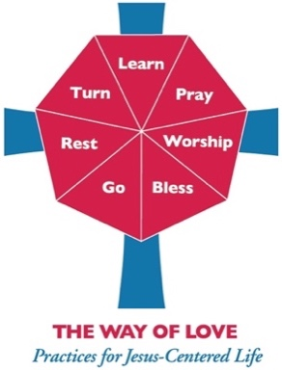
Tuesday, December 14
LEARN
Read Luke 1:59-80. When Zechariah’s speech returns, he praises God. If you lost the power to speak for nine months like Zechariah did, what would be your first word of praise? Share this with your family, friends, and on social media.

Wednesday, December 15
PRAY
Pray along with the Collect for Advent 3, found on page 212 in The Book of Common Prayer. How will prayer guide you through the rest of the week? Set aside special time today to focus your intentions on stirring up peace and spreading joy.

Thursday, December 16
BLESS
Spend a significant amount of time today discerning if there is a special blessing or gift you can share with your church, a local ministry, or with your community. Ask God to inspire and equip you with the fortitude and tools to make this gift something truly memorable and heartfelt.

Friday, December 17
TURN
Turn away from the busyness of the world right now. Turn your heart and mind toward giving thanks for this time of reflection, refreshment, and renewal. Turn your attention toward how you will be resting tomorrow, and put things in place so you can make the most of your sabbath time.

Saturday, December 18
REST
Spend at least 45 minutes outside today, without doing yard work or fixing lights or redoing bows on the garland. Take some time to just sit outside and let the air wash over you, taking away the stress and worry of the moment. Read Psalm 100 before and after your outside time. See how this psalm may help you rest and recharge your spirit.

