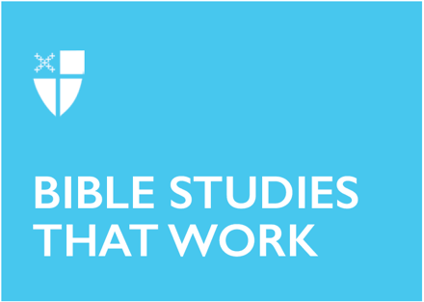

1 Christmas
December 26, 2021

RCL: Isaiah 61:10-62:3; Psalm 147 or 147:13-21; Galatians 3:23-25; 4:4-7; John 1:1-18

Isaiah 61:10-62:3
It is clear in the prophecy given to Isaiah that God intends for his people Israel to be a beacon to other nations. The strong imagery of “garland,” “jewels,” “crown,” and “diadem” bespeak a richness that God bestows upon those who are faithful to him. But these riches adorn his people for a single purpose: they are meant to be a sign to those who do not yet know the God of Israel. The gifts which God graciously gives his people are meant to draw others into relationship with him. The salvation we receive from the Father is meant not as a vindication of ourselves in the face of those who are perishing, but as a means to bring salvation to them. God intends Israel to be a torch to light the path for others.
- What gifts has God bestowed upon you? How might you use those gifts to draw others to God?

Psalm 147 or 147:13-21
Psalm 147 is a song of praise and thanksgiving which speaks directly about how God is faithful in keeping his promises to his people. Those to whom he is faithful are called to worship him. Our worship of God is all that we may offer in thanks for the renewal of life and bountiful provision we receive from him.
- “Word” is used in verses 16, 19, and 20. How might the meaning of “word” vary between these three verses?
- How does the coming of God’s Word in the person of Jesus Christ, who has been revealed to all nations, affect our understanding of the “chosen” quality of God’s people?

Galatians 3:23-25; 4:4-7
Paul’s epistle to the Galatian Church recognizes both the merit and limitations of “the law” – before the coming of Christ, the law stood as the means of covenant and relationship between Israel and God. The law was the previous means of claiming God as Father, but through his son, we may now claim in a truer sense to be sons and daughters of God the Father. Because the Word of God has taken our human flesh, our humanity is free to be united to the Father in a new way.
- Does our claim on God the Father free us from our responsibility to his law?
- To what are we heirs? What responsibilities does that heirship lay upon us?

John 1:1-18
John’s Gospel account varies greatly from the accounts of the Synoptic Gospels (Matthew, Mark, and Luke). Far more concerned with theological notions than the narratives that drive the other three accounts, his prologue jumps feet-first into some deep waters. Much of our understanding of the relationship between the Father and the Son, as expressed in the creeds of the Church, is drawn directly from this prologue. Recalling the creation story of Genesis, John assures us of the nature and authority of the Word who takes upon himself our human flesh, in order that he might live among us—and that we might truly live. The Word made flesh in the person of Jesus Christ calls us to grow into the lives he wills for us and to accept God as our Father. As in the letter to the Galatians, we see that the Son has come to fulfill what could not be realized by the law alone: true relationship with God the Father.
- What does John mean when he writes, “He came to what was his own, and his own people did not accept him”? How might this be related to the statements about “the law” in both John and Galatians?
- In what ways do our lives in Christ witness to his power? What is one concrete way that you might testify to the light of Christ?

This Bible study, written by Andrew Cruz Lillegard, originally ran for 1 Christmas in 2018.

