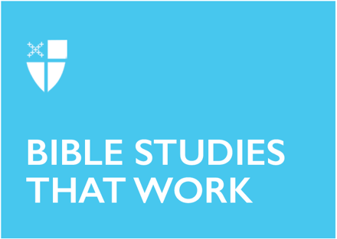

Christ the King Sunday (B)
November 21, 2021

RCL: 2 Samuel 23:1-7; Psalm 132:1-13 (14-19); Revelation 1:4b-8; John 18:33-37

Samuel 23:1-7
King David—perhaps the greatest King of Israel—in his final words, did not take credit for himself, but instead declared that it was God who had anointed and exalted him to his place of leadership. David credited God not only for his rise to power, but also for his ability to rule the people justly. David proclaimed, “One who rules over people justly, ruling in the fear of God, is like the light of morning, like the sun rising on a cloudless morning, gleaming from the rain on the grassy land.” Godly leadership was not simply the right thing to do for King David, but it was a thing of great beauty. David understood that to use our positions of authority and influence for good and just purposes is to make our houses, our tiny kingdoms, like the Kingdom of God.
- In what positions of authority do you serve where you could invite the Kingdom of God to be made present?
- What is something small you could do today to make your house more like the Kingdom of God?

Psalm 132:1-13 (14-19)
The Psalmist reminds us, the readers, of King David’s commitment to building a temple, a dwelling place for God. This commitment was not simply a line item which could sit on the back burner, nor was it a campaign promise that would stir the hearts of the people to support him, even if it were never fully realized. Instead, King David made the creation of a place for God to dwell a priority in both his life and leadership. David vowed, “I will not come under the roof of my house, nor climb up into my bed; I will not allow my eyes to sleep, nor let my eyelids slumber; Until I find a place for the Lord, a dwelling for the Mighty One of Jacob.” This prioritization and relentless pursuit of creating a space for God in the midst of the people of Israel became the desire of David’s heart. Imagine how we might harness our own authority to serve others if our desire were to ensure that God lived within our midst.
- Where have you created space for God in your own life?
- Where else in your life could you prioritize creating a space for God to dwell?

Revelation 1:4b-8
The scene that is described for us here in the first chapter of Revelation is one of a king arriving and there being no mistake regarding who he is or why he has come. The author declares, “Look! He is coming with the clouds; every eye will see him, even those who pierced him; and on his account all the tribes of the earth will wail.” In this foretelling of Christ’s second coming, the Messiah is returning to the earth in an unmistakable fashion, befitting a king. This is most unlike his first inbreaking, when he arrived without the expected pomp and circumstance and instead came into the world as an infant, totally dependent upon those who would raise him up. This Jesus, he is the Messiah King, the “ruler of the kings of the earth,” who breaks into the world in surprising ways, not only to change the course of history, but also to invite the whole world to participate and become his Kingdom on earth.
- How did Jesus come into your life and in what way(s) did his arrival surprise you?
- In what practical ways can you live in the Kingdom of God in your everyday life?

John 18:33-37
When questioned by Pontius Pilate, Jesus answered, “My kingdom is not from this world.” This statement would be more surprising if it were the first time we encountered Jesus describing the Kingdom of God, but the more we hear about God’s Kingdom, the more we understand that it is very much upside-down or in reverse in comparison to the world as we know it. While our world so often operates on systems of scarcity and determining value based on supply and demand, in God’s Kingdom, there is not only enough for everyone, but there is abundance. In God’s Kingdom, all have enough and no one wants for anything. It is in this Kingdom that we can be loosed from the bondage of impulse and endless desire and finally be free to find eternal contentment in the One who had freed us. This is the good news that Christ our King came into the world to proclaim, and all who belong to the truth will listen to his voice.
- In what ways do you imagine that the Kingdom of God is different from the world today?
- In what small ways could we act to change our daily lives to allow the Kingdom of God to break in?

This Bible study, written by Joshua Woods, originally ran for Christ the King Sunday in 2018.

