October 24, 2021 – Pentecost 22 (B)

Young Adult and Campus Ministry Grants 2022

The Episcopal Church offers grants each year to assist with Young Adult and Campus Ministries throughout the church. This is a three-step process that includes discernment and planning, writing the application, and online submission. This process is designed to help you discern where and how God is calling your community to serve young adults and whether now is the right time to apply for a grant. We hope this process is an invitation for you and your community to consider how The Episcopal Church can minister with young adults on and off college campuses (including community colleges and tribal college campuses, non-traditional degree programs), in the military, and those who are not in college.
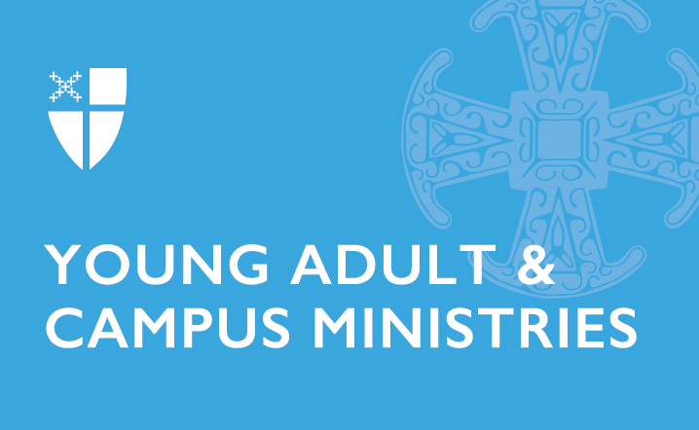
Eligibility
These grants are intended to provide funding for an Episcopal ministry (or ecumenical ministry with an Episcopal presence) in a diocese, congregation, or college/university that is currently engaging in or seeking a new relationship with young adults on and off college campuses.

Amount, Duration, and Categories of Grants
A total of $133,000 is available for this cycle. These grants are for the 2022-23 academic year. Deadline for submitting grants is November 1, 2021. There are four categories of grants:
- Development Grant: establish a new, restore a dormant, or reenergize a current ministry. Grant ranges from $8,000-30,000 and can be used over a two-year period. Development Grants can only be awarded to a specific ministry once every 5 years.
- Campus Ministry Grants: provide seed money to assist in the start-up of new, innovative campus ministries or to enhance a current ministry. Grants $1,000-8,000.
- Young Adult Ministry Grants: provide seed money to assist in the start-up of new, innovative young adult ministries or to enhance a current ministry. Grants $1000-8,000.
- Project Grants: provide money for a one-time project that will enhance and impact the campus or young adult ministry. Grants $100-2,000.

Discernment and Planning
Developing a grant application is best done in a community where colleagues and supporters can discern and explore where God is calling your ministry to grow, change, or do something new. If you are a solo minister, we invite you to think about who you should gather together to help you in this process. Many turn to their board or vestry, advisors, student ministers, and/or colleagues from your school or diocese to begin praying and exploring together. We strongly encourage you to use the Discernment and Planning Guide that can be found on the Grants webpage.

Learn more about Young Adult and Campus Ministry Grants at iam.ec/yacm2021.

