January 30, 2022 – Epiphany 4 (C)

Global Partnerships Lectio Divina: The Very Rev. Sally Sue Hernández and the Rev. Glenda McQueen

The season of Epiphany is when we celebrate the revealing of Christ to the world. We mark the arrival of the One who is the light of the world: a light that brings life, a light that brings hope. This light shines its brightest when we are in community - with God and with one another. The Office of Global Partnerships of The Episcopal Church invites individuals, small groups, congregations, and dioceses to use our weekly video series throughout the season of Epiphany to draw closer to each other and our Lord. Using an adaptation of lectio divina with the gospel passage for each Sunday, you’ll meet and hear from Episcopalians and Anglican partners from around the world as they read and reflect on Jesus’ revelation to us.
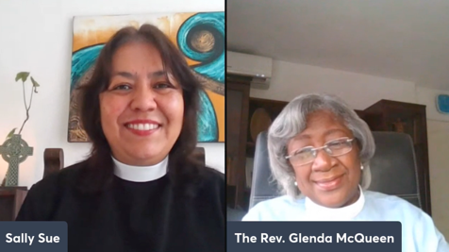
This week’s lectio divina features the Rev. Glenda McQueen, Episcopal Church Partnership Officer for Latin America and the Caribbean, and the Very Rev. Sally Sue Hernández, Dean of the Catedral Anglicana de San José de Gracia, in the Anglican Church of Mexico. Watch their discussion at iam.ec/epiphany2022 and follow along by yourself or in a small group. To participate:

1. Read today’s Gospel passage:
Jesus began to speak in the synagogue at Nazareth: “Today this scripture has been fulfilled in your hearing.” All spoke well of him and were amazed at the gracious words that came from his mouth. They said, “Is not this Joseph’s son?” He said to them, “Doubtless you will quote to me this proverb, ‘Doctor, cure yourself!’ And you will say, ‘Do here also in your hometown the things that we have heard you did at Capernaum.’” And he said, “Truly I tell you, no prophet is accepted in the prophet’s hometown. But the truth is, there were many widows in Israel in the time of Elijah, when the heaven was shut up three years and six months, and there was a severe famine over all the land; yet Elijah was sent to none of them except to a widow at Zarephath in Sidon. There were also many lepers in Israel in the time of the prophet Elisha, and none of them was cleansed except Naaman the Syrian.” When they heard this, all in the synagogue were filled with rage. They got up, drove him out of the town, and led him to the brow of the hill on which their town was built, so that they might hurl him off the cliff. But he passed through the midst of them and went on his way. (Luke 4:21-30, NRSV)

2. Reflect:
Which word or short phrase caught your attention or came to mind? Whether you’re alone or in a group, say it aloud.

3. Read:
Reread the passage, perhaps in a different translation. In this week’s video, you’ll hear the text in Portuguese.

4. Reflect:
Where does the passage touch your life today? If you’re with a group, share your responses with each other, without discussing further. If you’re alone, say your response aloud or write it down.

5. Read:
Reread the passage, perhaps in yet another translation.

6. Reflect:
From what I’ve heard and shared, what do I believe God wants me to do or be? Is God inviting me to change in any way? You might consider journaling out your response and meditating on it over the course of this week.

7. Pray:
In closing, say the Lord’s Prayer, today’s collect, or the Collect for Proper 28 in the Book of Common Prayer (p. 236).

