February 6, 2022 – Special Bulletin Insert

The Absalom Jones Fund for Episcopal HBCUs

Episcopal Church Presiding Bishop Michael Curry invites people of all backgrounds and faiths to support the hope-filled, life-impacting work of two historically Black institutions of higher education through donations and dedicated offerings on the Feast of Absalom Jones—the first Black priest ordained by the church—observed Feb. 13.

Saint Augustine’s University in Raleigh, North Carolina, and Voorhees College in Denmark, South Carolina, were founded after the Civil War to create educational opportunities for formerly enslaved people. They provide a liberal arts education to thousands of students, as well as offer robust campus ministries to help form young adults as followers of Jesus and his way of love.

“Historically Black colleges and universities (HBCUs) are essential engines of justice, equity, and social mobility,” Curry said. “They provide high-quality education to students whose backgrounds and experiences may not have prepared them

February 6, 2022 – Special Bulletin Insert

The Absalom Jones Fund for Episcopal HBCUs

Episcopal Church Presiding Bishop Michael Curry invites people of all backgrounds and faiths to support the hope-filled, life-impacting work of two historically Black institutions of higher education through donations and dedicated offerings on the Feast of Absalom Jones—the first Black priest ordained by the church—observed Feb. 13.

Saint Augustine’s University in Raleigh, North Carolina, and Voorhees College in Denmark, South Carolina, were founded after the Civil War to create educational opportunities for formerly enslaved people. They provide a liberal arts education to thousands of students, as well as offer robust campus ministries to help form young adults as followers of Jesus and his way of love.

“Historically Black colleges and universities (HBCUs) are essential engines of justice, equity, and social mobility,” Curry said. “They provide high-quality education to students whose backgrounds and experiences may not have prepared them

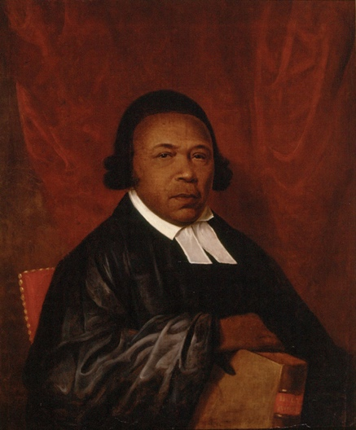
well for college success. They nurture talent that may have otherwise been discouraged by obstacles.”

Donations to the HBCUs (divided equally between the two) help support scholarships and financial aid for students in need as well as funding for quality facilities, faculty recruitment and retention, and the development of religious life on campus. Voorhees and Saint Augustine’s are seeking to build strong programs in STEM fields and the health sciences as they overcome the financial pressures created by COVID-19.

Supporting HBCUs is an investment in the ministry of reconciliation and building a better future for all, Curry said. “As much as we give to these institutions, they give back to our world many times over,” he said.

To give: Make a donation online at iam.ec/givehbcu, or text GIVEHBCU to 41444.

For questions or additional information, email Cecilia Malm, associate director/senior development officer, at cmalm@episcopalchurch.org, or call (212) 716-6062.

well for college success. They nurture talent that may have otherwise been discouraged by obstacles.”

Donations to the HBCUs (divided equally between the two) help support scholarships and financial aid for students in need as well as funding for quality facilities, faculty recruitment and retention, and the development of religious life on campus. Voorhees and Saint Augustine’s are seeking to build strong programs in STEM fields and the health sciences as they overcome the financial pressures created by COVID-19.

Supporting HBCUs is an investment in the ministry of reconciliation and building a better future for all, Curry said. “As much as we give to these institutions, they give back to our world many times over,” he said.

To give: Make a donation online at iam.ec/givehbcu, or text GIVEHBCU to 41444.

For questions or additional information, email Cecilia Malm, associate director/senior development officer, at cmalm@episcopalchurch.org, or call (212) 716-6062.

