February 6, 2022 – Epiphany 5 (C)

Global Partnerships Lectio Divina: The Diocese of New York and the Diocese of Central Tanganyika

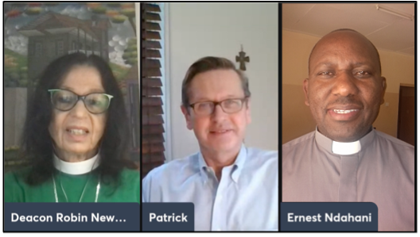
The season of Epiphany is when we celebrate the revealing of Christ to the world. We mark the arrival of the One who is the light of the world: a light that brings life, a light that brings hope. This light shines its brightest when we are in community - with God and with one another. The Office of Global Partnerships of The Episcopal Church invites individuals, small groups, congregations, and dioceses to use our weekly video series throughout the season of Epiphany to draw closer to each other and our Lord. Using an adaptation of lectio divina with the gospel passage for each Sunday, you’ll meet and hear from Episcopalians and Anglican partners from around the world as they read and reflect on Jesus’ revelation to us.

This week’s lectio divina features Mr. Patrick Kidd, chair of the Diocese of New York’s Global Mission Commission, Canon Ernest Ndahini of the Msalato Theological College, Central Tanganyika Diocese, in the Anglican Church of Tanzania, and Deacon Robin Newman, chair of the Diocese of New of York’s Tanzania Task Force. Watch their discussion at iam.ec/epiphany2022 and follow along by yourself or in a small group. To participate:

1. Read today’s Gospel passage:
Once while Jesus was standing beside the lake of Gennesaret, and the crowd was pressing in on him to hear the word of God, he saw two boats there at the shore of the lake; the fishermen had gone out of them and were washing their nets. He got into one of the boats, the one belonging to Simon, and asked him to put out a little way from the shore. Then he sat down and taught the crowds from the boat. When he had finished speaking, he said to Simon, “Put out into the deep water and let down your nets for a catch.” Simon answered, “Master, we have worked all night long but have caught nothing. Yet if you say so, I will let down the nets.” When they had done this, they caught so many fish that their nets were beginning to break. So they signaled their partners in the other boat to come and help them. And they came and filled both boats, so that they began to sink. But when Simon Peter saw it, he fell down at Jesus' knees, saying, “Go away from me, Lord, for I am a sinful man!” For he and all who were with him were amazed at the catch of fish that they had taken; and so also were James and John, sons of Zebedee, who were partners with Simon. Then Jesus said to Simon, “Do not be afraid; from now on you will be catching people.” When they had brought their boats to shore, they left everything and followed him. (Luke 5:1-11, NRSV)

2. Reflect:
Which word or short phrase caught your attention or came to mind? Whether you’re alone or in a group, say it aloud.

3. Read:
Reread the passage, perhaps in a different translation. In this week’s video, you’ll hear the text in Portuguese.

4. Reflect:
Where does the passage touch your life today? If you’re with a group, share your responses with each other, without discussing further. If you’re alone, say your response aloud or write it down.

5. Read:
Reread the passage, perhaps in yet another translation.

6. Reflect:
From what I’ve heard and shared, what do I believe God wants me to do or be? Is God inviting me to change in any way? You might consider journaling out your response and meditating on it over the course of this week.

7. Pray:
In closing, say the Lord’s Prayer, today’s collect, or the Collect for Proper 28 in the Book of Common Prayer (p. 236).

