The 100th Anniversary of the Good Friday Offering

شكرا • תודה • Thank you
In any language, the phrase “thank you” means the same thing: an expression of gratitude for an action that has made a difference. As we celebrate the centenary of the Good Friday Offering this year, gratitude is on the lips and in the hearts of many people whose lives have been changed because of your generosity.

The Anglican Province of Jerusalem and the Middle East recognizes the importance of presence—of following our Lord’s model of unconditionally loving people first. With your gifts, the Good Friday Offering has helped fund the following:

- The Mission to Seafarers in the United Arab Emirates, where ships are loaded not only with goods but also sailors and other workers who labor for long hours thousands of miles from home.
- The Arab Episcopal School in Irbid, Jordan, which provides a strong educational program for blind students.
- St. Christopher’s Cathedral in Bahrain, which focuses on providing food and other care for migrant workers who have lost their jobs and cannot get a flight back to their home countries.
- Arab Ahli Hospital in Gaza, a ministry that works tirelessly, despite shortages of medical disposables, medicine, fuel for electrical generators, and food assistance for the poor.
- And many more important ministries across the region.

The 100th Anniversary of the Good Friday Offering

شكرا • תודה • Thank you
In any language, the phrase “thank you” means the same thing: an expression of gratitude for an action that has made a difference. As we celebrate the centenary of the Good Friday Offering this year, gratitude is on the lips and in the hearts of many people whose lives have been changed because of your generosity.

The Anglican Province of Jerusalem and the Middle East recognizes the importance of presence—of following our Lord’s model of unconditionally loving people first. With your gifts, the Good Friday Offering has helped fund the following:

- The Mission to Seafarers in the United Arab Emirates, where ships are loaded not only with goods but also sailors and other workers who labor for long hours thousands of miles from home.
- The Arab Episcopal School in Irbid, Jordan, which provides a strong educational program for blind students.
- St. Christopher’s Cathedral in Bahrain, which focuses on providing food and other care for migrant workers who have lost their jobs and cannot get a flight back to their home countries.
- Arab Ahli Hospital in Gaza, a ministry that works tirelessly, despite shortages of medical disposables, medicine, fuel for electrical generators, and food assistance for the poor.
- And many more important ministries across the region.
Thank you for the difference you are making through the Good Friday Offering in the lives of a wide diversity of people throughout Jerusalem and the Middle East. “Shukran,” “toda,” thank you, for helping us and our worldwide ministry partners become a church that looks and acts like Jesus.

In this time of exceptional circumstances, please make a gift to the Good Friday Offering in one of the following ways:

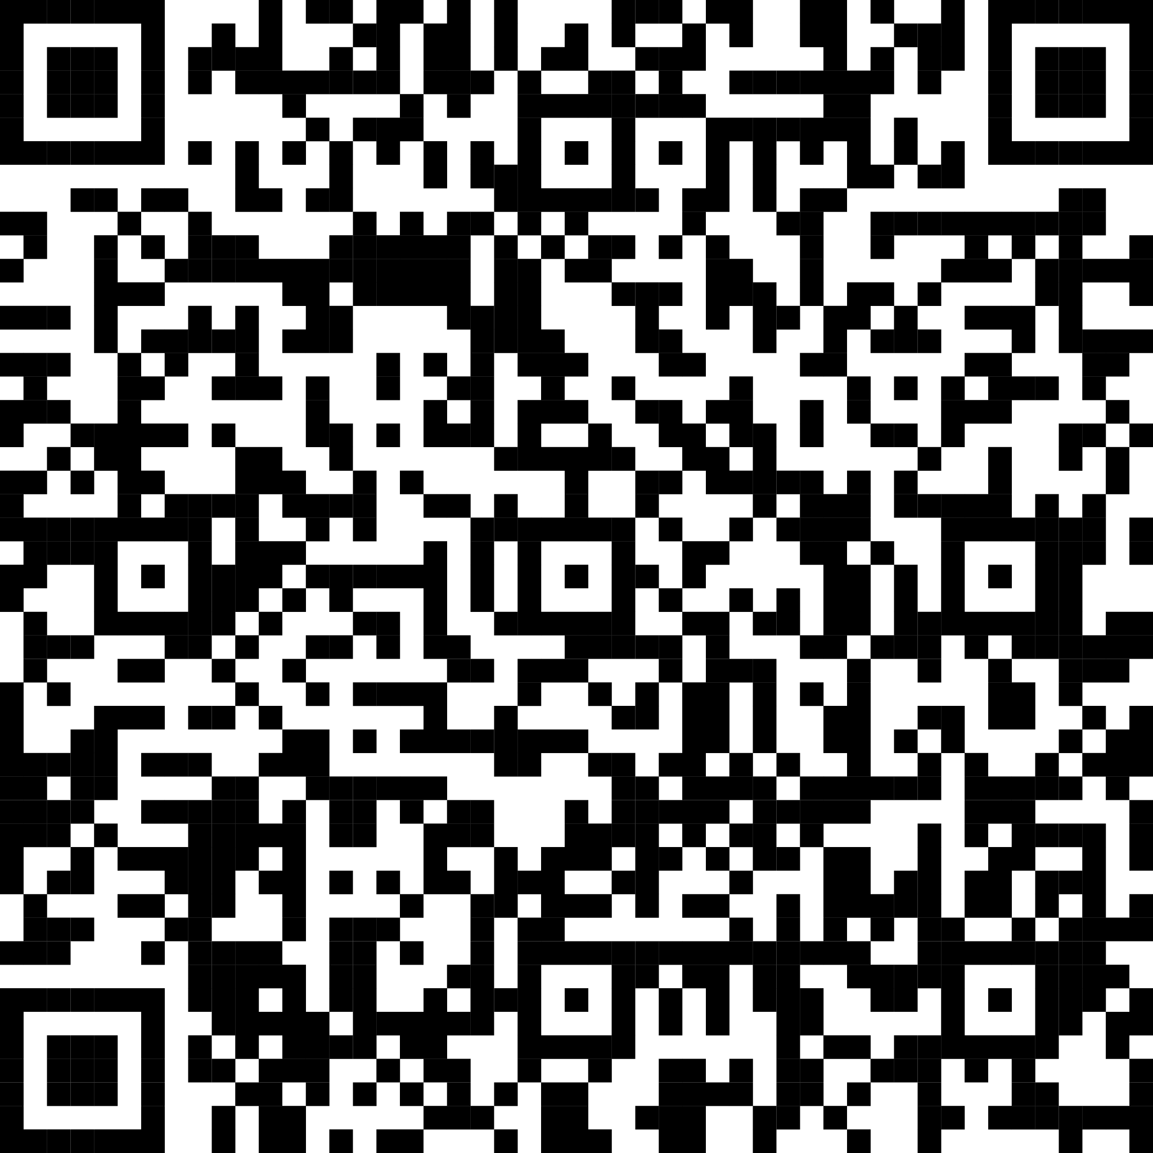
- Scan the QR code here:

- Give securely online at iam.ec/goodfridayoffering
- To give via phone or for gifts of stock,
call (800) 334-7626 x6002
- You can also still send your check contribution by mail to:
DFMS-Protestant Episcopal Church US
P.O. Box 958983
St. Louis, MO 63195-8983
Make your check payable to: The Domestic and Foreign Missionary Society with “Good Friday Offering” in the memo field. Thank you.

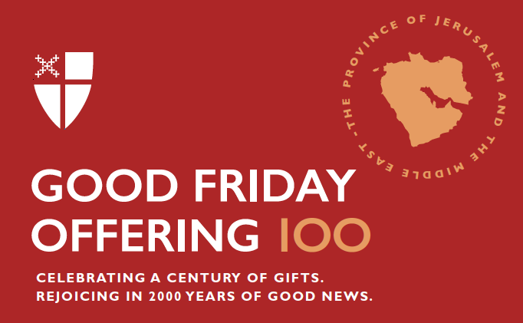

Thank you for the difference you are making through the Good Friday Offering in the lives of a wide diversity of people throughout Jerusalem and the Middle East. “Shukran,” “toda,” thank you, for helping us and our worldwide ministry partners become a church that looks and acts like Jesus.

In this time of exceptional circumstances, please make a gift to the Good Friday Offering in one of the following ways:

- Scan the QR code here:

- Give securely online at iam.ec/goodfridayoffering
- To give via phone or for gifts of stock,
call (800) 334-7626 x6002
- You can also still send your check contribution by mail to:
DFMS-Protestant Episcopal Church US
P.O. Box 958983
St. Louis, MO 63195-8983
Make your check payable to: The Domestic and Foreign Missionary Society with “Good Friday Offering” in the memo field. Thank you.

