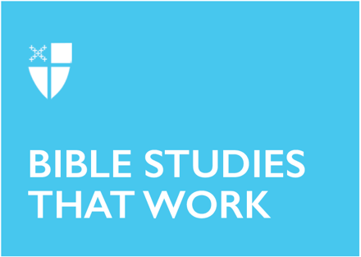

Easter 3 (C)
May 1, 2022

RCL: Acts 9:1-20; Psalm 30; Revelations 5:11-14; John 21:1-19

Acts 9:1-20
Have you ever encountered someone you hadn’t seen in a while who has completely changed for the better? Maybe a high school or university acquaintance, a cousin or other family member? Memories of taunting or even simply discomfort because of the way they previously acted might arise. Yet – they’ve changed! Really changed. They seem sweet and maybe much humbler than you remember. Our memories get confusing because you know something happened that way, and it probably did! Now, though, you find it hard to dislike them.

Somewhere along the way, they had a Damascus moment. You don’t know what happened, but they seemed to have learned something profound. Perhaps you got an apology out of it. Reconciliation, thanks be to God! Maybe for them, a close death or near death experience, the harrowing of a relationship or health problem that they went through gave them a new perspective. Perhaps you’re that person and you’ve come a long way since that former self. The harshest conversions, though, can be the most difficult to accept for us. But this is between God and the person, isn’t it? Ananias is an example for us today. We might have a few questions about security, for sure, but we put away our pride and follow the Christian example to love and welcome those along our way, no matter their past.
- Where is God amid a difficult relationship?
- Perhaps you remember a time when you weren’t as welcoming and loving as you should have been. What did you learn from this experience and how did you grow?

Psalm 30
“Weeping may spend the night, but joy comes in the morning” sounds very much like a modern cliché we might hear, along the lines of “It’s always darkest just before the dawn.” While I don’t know if that’s scientifically accurate, I do know that I find myself refreshed after a nap or full sleep after I’ve cried or had an emotional time with something or someone. I feel this is what the psalmist has also gone through. Yet, through God’s power and might, he lifts us up. He rescues us from fear and from the Pit. He hears our cries and turns them around into shouts of joy, praise, and thanksgiving. Our tears are redeemed.
- How has God redeemed the tears in your life?
- Symbolically speaking and if you can share, what did the night look like? What did the morning look like?

Revelations 5:11-14
Usually, when the title “Lamb of God” comes up, it’s in the context of “Lamb of God, you take away the sins of the world.” But here we have a much more vivid picture: The Lamb who has been slaughtered, yet who has received much in return. This Lamb is worshipped along with the one seated on the throne.

In a broader context, the four living creatures and the elders were introduced earlier in Chapter 4. Many have speculated those living creatures (lion, ox, eagle, and human) represent the four Gospels. The fact that they declare, “Amen!” certainly adds intrigue to this idea. There are twenty-four elders, which I find interesting; we are so accustomed to the number 12 in scripture, but now we have doubled that. Could the elders represent all humankind? Both Jew and Gentile? Man and woman? In any event, all fell down and worshiped.
- What is your favorite practice in your private and/or public worship?

John 21:1-19
This passage is full of rich details, isn’t it? Nathanael is from Cana; maybe he was the groom of the wedding? Peter is naked. The fire is a charcoal fire, not a wood fire. The number of fish is 153. We also know the story takes place early in the morning, which is the best time to catch fish. But none of these details is as important as the answer Jesus seeks: “Do you love me?” “Feed my sheep.” “Follow me.” (Though we get in one last detail: a prediction of Peter’s death.)
- In what ways do you follow Jesus as the unique person you are?
- What’s one detail about Jesus’ life and ministry that you hold close?

This Bible study was written by Zachary Baker, a seminarian at Virginia Theological Seminary.

