Easter 2 (C)

Locked Doors
[RCL] Acts 5:27-32; Psalm 118:14-29 or Psalm 150; Revelation 1:4-8; John 20:19-31

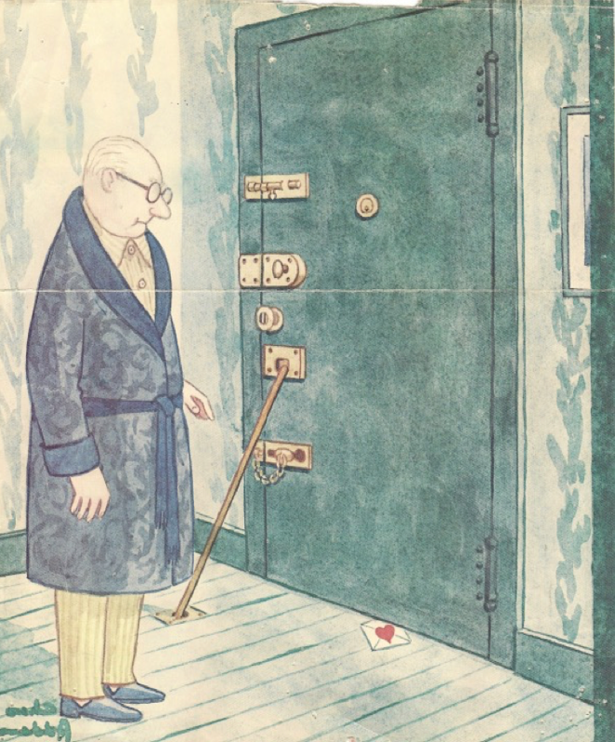
Today’s sermon illustration is that odd picture that’s included. It’s an old Charles Addams cover from a 1981 New Yorker magazine. The image shows a typical affluent Addams New Yorker standing at the door inside his apartment. The door is made of steel and it has four locks and a security bar. Underneath the door is a small envelope with a large red heart on it. The cover was published for Valentine’s Day, but perhaps it could be about today, about the Second Sunday of Easter—low Sunday.

Every year on this Sunday, we hear the same Gospel, which is John’s telling of the story of Easter Day and the first Sunday after Easter Day. And while Thomas often gets most of the attention, today is really all about the heart of the faith—about who we are and who God is; it’s about what we can and can’t do; and it’s about this little picture.

First of all, today is about locked doors. The disciples are hiding behind locked doors because they’re afraid. They’re afraid of the religious leaders; they’re afraid of the crowds; and they’re probably afraid of a Messiah who has come back from the dead and who just might want to settle scores with a bunch of cowardly disciples who had, quite literally, left him hanging. For whatever reason, the doors are locked.

And so is the door in this picture. This is doubtless a much more stylish door than the one the disciples hid behind. It’s a wonderful door, really—the ultimate symbol of success and security. This door is what it looks like when you’ve made it, when you’ve scratched and clawed all the way to the top, to the penthouse. It’s steel, with three locks, plus a chain, plus a bar. What more could anyone want; what better status symbol? No one can get in, and he’s safe; all of his stuff is safe; and nothing can happen to him now. It doesn’t get any better than this. Or any worse.

The two of these together, the Gospel and this little picture, pretty much tell it like it is. We all know about locked doors—about things that keep us inside and limited and away from the most there can be. We all have our personal locks, things like fear and doubt and anger and resentments, things like our own personal history, our own wounds, our own self-righteousness and pride, and, of course, our own sin. We all have what it takes to put ourselves in the picture—in this picture and pictures like it.

In many ways, this is the natural human condition. We’re all like this. Part of what it means to be a human being, to be a person in the world, is to live behind closed and locked doors—sometimes it’s because that’s what we want, sometimes it’s in spite of what we want, sometimes it’s even though we desire desperately for ourselves and our lives to be different. In all its forms, this is part of what it means to be a person. One fancy term for it is alienation, being separated, in fundamental ways, from the natural world, from each other, from God, and from ourselves.

There are all sorts of ways of talking about this reality. It underlies the entire Biblical story, starting with creation and the fall. Scripture insists that there is something fundamentally incomplete and broken about us, something in need of divine mending. Alienation is an aching for wholeness that’s always just beyond our reach. St. Augustine says the human heart is restless, all by itself. Others say that we are created with a hole in our souls, a hole that has the shape of a cross, and that we will never be complete until that hole is filled with the one thing that fits it.

Living behind locked doors is another image of the same thing, another way of describing the reality of alienation that is as fundamental as it is painful. We can be as scared and miserable as the disciples in their locked room, or as smug and prosperous as this well-dressed fellow. But the door is still locked, and we still know that.

Also, note that so much of what we do when we are at our worst comes from trying to fix this emptiness on our own.

So much of the really dreadful stuff we do to ourselves and to each other is the result of realizing that there’s something wrong—and trying to find a person, or a program, or a pastime, or a substance, or a belief, or a new thing, or more of something, or a whatever, that will either get us out of the box we realize we’re in, or make us comfortable and happy, or at least numb and pain-free, while we continue to live in it.

But these never work, not for the long haul. We discover that not only are we basically limited and incomplete but also that we can’t fix this all by ourselves. When we try, we just make a bigger mess than we started out with.

Easter, of course, is about the fact that God comes through the locked doors and offers us himself and his peace. He gives us his love, and he offers us the possibility of faith, and of new life. And it’s all a gift—slid under our locked doors. In the gospel story, the disciples don’t do anything noble, heroic, or even mildly admirable. Remember, the last things they showed Jesus were their backs as they ran away. The last thing we heard from Peter was his denying three times that he even knew Jesus. After that, the disciples just hide out. That’s all they do. But Jesus comes through the locks and he offers peace.

Then, a week later, Jesus again appeared to the disciples. Notice what they have done that week. They have kept the doors locked, and they have failed even to convert Thomas—the testimony of the entire church wasn’t persuasive or compelling enough to convince the one guy who really wants to believe. (In fact, this isn’t really a story about “Doubting Thomas”; it’s a story about the unpersuasive disciples.)

And once more, the Lord comes to them. Once more, he comes without conditions, without demands, without recriminations, and without rancor. Even though the doors are locked; even though they haven’t done a single thing worth writing home about; even though by low Sunday they haven’t added a single convert—still, the Lord comes to them, and, like God over the form of Adam in Genesis, continues to breathe his Spirit into them, and to make new life possible.

So it is with the picture. The fellow here didn’t leave any open spaces on purpose. He did the very best he could to be closed off, secure and unreachable. But a way is found, and the completely unexpected and unmerited gift is given. He gets a valentine; he gets a sign of love from beyond all his locks and bars.

In fact (and even though the artist doubtless didn’t intend this point), what he gets is the heart of Jesus and the wounds of Jesus. He receives the same thing the disciples and Thomas and we receive. It’s just there, for him.

For all of our struggles to find something to fix us, to fill the holes inside us, to get ourselves out of the prisons we find ourselves in, for all of the effort and for all of the tragedy that are so often a part of that search—the answer turns out to be not a task for us to accomplish, or a truth we have to learn, or a ceremony we have to perform. The answer is that little heart slid under the door, an impossible presence in a locked room. The answer is a gift we are offered and invited to receive.

Maybe low Sunday, with its “back to normal” reminder that we aren’t always quite as wonderful and as potent as we might be led to believe after a magnificent Holy Week and Easter, maybe this is a good time to remember that we really don’t have to do anything. We just stand there, afraid, behind locked doors.

What really matters, the healing of our pain and of the world’s pain, the great promise of rest and peace and wholeness, is a gift. We do nothing. God does everything.

The Rev. James Liggett is the retired rector of St. Nicholas’ Episcopal Church in Midland, Texas. He is a native of Kansas and a graduate of the University of Houston and the Episcopal Divinity School. He has served parishes in Kansas, Texas, and Oklahoma and has been a contributor to Sermons That Work since the 1980’s. His e-mail is Jim@liggetts.org.

