June 26, 2022 – Pentecost 3 (C)

The Feast of St. Peter and St. Paul

On June 29th, the Church will remember the martyrdoms of Sts. Peter and Paul, apostles and martyrs.

While there are no explicit testaments to the deaths of St. Peter or St. Paul in Scripture, and though they were not martyred at the same time, tradition has placed the commemoration of their deaths together, as a result of the Neronian persecution of Christians in 64 A.D. Placing the commemoration on June 29th was likely a reference to an event in 258 A.D. when the remains of the martyrs were moved from their resting places to avoid desecration during persecutions ordered by Valerian.

According to Holy Women, Holy Men, the martyrdoms of these apostles were markedly different. The book records, “As a Roman citizen, Paul would probably have been beheaded with a sword” (HWHM, 446). His death would have been faster and less painful than that of Peter, who, tradition holds, was crucified upside-down at his own request, considering himself unworthy of dying the same way as Jesus.

Images of Sts. Peter and Paul often include the instruments of their martyrdoms. Paul may be depicted holding a sword and holding open a book that reads “Spiritus Gladius,” or “sword of the Spirit.” This references both Paul’s beheading with a sword and his letter to the Ephesians, in which he asks the Church to take up “the sword of the Spirit, which is the word of God” (Eph. 6:17). Peter, along with his traditional symbols of keys to the kingdom of heaven, is regularly depicted with an inverted cross.

June 26, 2022 – Pentecost 3 (C)

The Feast of St. Peter and St. Paul

On June 29th, the Church will remember the martyrdoms of Sts. Peter and Paul, apostles and martyrs.

While there are no explicit testaments to the deaths of St. Peter or St. Paul in Scripture, and though they were not martyred at the same time, tradition has placed the commemoration of their deaths together, as a result of the Neronian persecution of Christians in 64 A.D. Placing the commemoration on June 29th was likely a reference to an event in 258 A.D. when the remains of the martyrs were moved from their resting places to avoid desecration during persecutions ordered by Valerian.

According to Holy Women, Holy Men, the martyrdoms of these apostles were markedly different. The book records, “As a Roman citizen, Paul would probably have been beheaded with a sword” (HWHM, 446). His death would have been faster and less painful than that of Peter, who, tradition holds, was crucified upside-down at his own request, considering himself unworthy of dying the same way as Jesus.

Images of Sts. Peter and Paul often include the instruments of their martyrdoms. Paul may be depicted holding a sword and holding open a book that reads “Spiritus Gladius,” or “sword of the Spirit.” This references both Paul’s beheading with a sword and his letter to the Ephesians, in which he asks the Church to take up “the sword of the Spirit, which is the word of God” (Eph. 6:17). Peter, along with his traditional symbols of keys to the kingdom of heaven, is regularly depicted with an inverted cross.
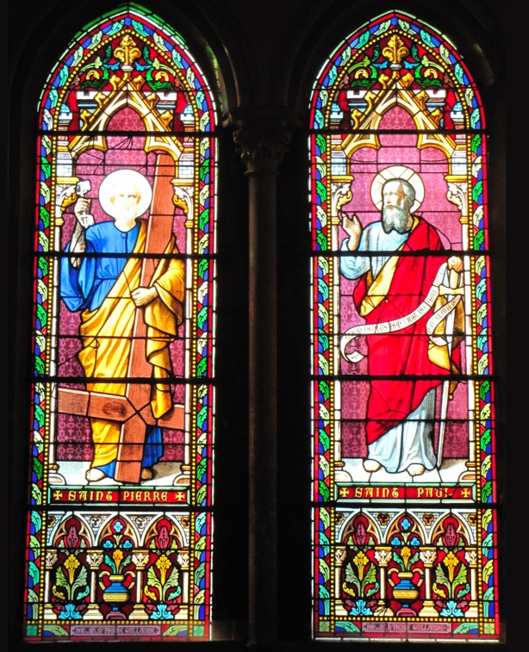
The relationship between the two can be instructive to us as modern-day Christians. From Holy Women, Holy Men, “Paul, the well-educated and cosmopolitan Jew of the Dispersion, and Peter, the uneducated fisherman from Galilee, had differences of opinion in the early years of the Church concerning the mission to the Gentiles. More than once, Paul speaks of rebuking Peter for his continued insistence on Jewish exclusiveness; yet their common commitment to Christ and the proclamation of the Gospel proved stronger than their differences; and both eventually carried that mission to Rome” (HWHM, 446). Where might we within the Church learn to appreciate each other’s differing viewpoints? How can our common commitment to Jesus Christ and the Gospel carry us to the testing ground and beyond?
Stained glass, Sts. Peter and Paul and the instruments of their martyrdoms. Church of St. Thomas, Jersey

Collect for St. Peter and St. Paul
Almighty God, whose blessed apostles Peter and Paul glorified you by their martyrdom: Grant that your Church, instructed by their teaching and example, and knit together in unity by your Spirit, may ever stand firm upon the one foundation, which is Jesus Christ our Lord; who lives and reigns with you, in the unity of the Holy Spirit, one God, for ever and ever.

The relationship between the two can be instructive to us as modern-day Christians. From Holy Women, Holy Men, “Paul, the well-educated and cosmopolitan Jew of the Dispersion, and Peter, the uneducated fisherman from Galilee, had differences of opinion in the early years of the Church concerning the mission to the Gentiles. More than once, Paul speaks of rebuking Peter for his continued insistence on Jewish exclusiveness; yet their common commitment to Christ and the proclamation of the Gospel proved stronger than their differences; and both eventually carried that mission to Rome” (HWHM, 446). Where might we within the Church learn to appreciate each other’s differing viewpoints? How can our common commitment to Jesus Christ and the Gospel carry us to the testing ground and beyond?
Stained glass, Sts. Peter and Paul and the instruments of their martyrdoms. Church of St. Thomas, Jersey

Collect for St. Peter and St. Paul
Almighty God, whose blessed apostles Peter and Paul glorified you by their martyrdom: Grant that your Church, instructed by their teaching and example, and knit together in unity by your Spirit, may ever stand firm upon the one foundation, which is Jesus Christ our Lord; who lives and reigns with you, in the unity of the Holy Spirit, one God, for ever and ever.

