August 7, 2022 – Pentecost 9 (C)

Gifts to the Church by Episcopal Convents and Monasteries:

The Community of St. John Baptist
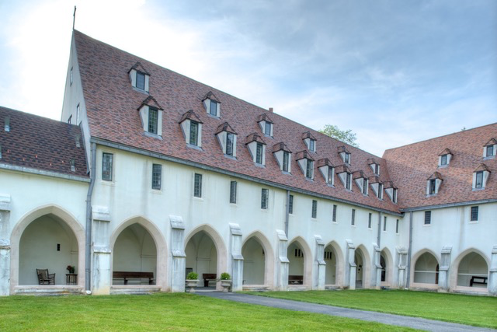
The Community of St. John Baptist describes their offerings of spiritual direction.

What is spiritual direction?
The majority of our Sisters are trained and certified Spiritual Directors. We work with individuals to improve their prayer life in order to deepen their connection with God. We also help directees with difficult theological questions and spiritual struggles.

Why is spiritual direction important?
Now, more than ever, people are seeking to find meaning in their lives. Working with a spiritual director can help people overcome religious trauma, learn new ways of engaging with scripture and ministry, and gain strength and comfort from a close relationship with the Divine.

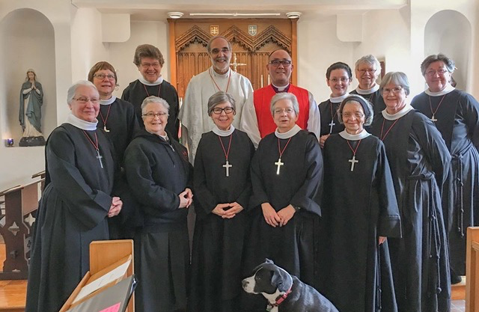
How is the Community of St. John Baptist involved in spiritual direction?
Since the beginning of the pandemic, the number of people seeking our Sisters out for spiritual direction has nearly tripled. We have shifted from seeing people in person to meeting with directees on Zoom or by phone. Directees can also take walks outdoors with us on our peaceful, prayerful campus or they can stay overnight at our guest cottage for individual guided retreats.

How can someone find a spiritual director?
Those interested in spiritual direction can contact their priest or bishop or contact a local religious community. Most Sisters, Brothers, and Friars are trained in spiritual direction. To contact CSJB, just email srmc@csjb.org or call 973-543-4641 ext. 2. Our website is www.csjb.org.

