July 24, 2022 – Pentecost 7 (C)

Ministry Resources for Lambeth

The Lambeth Conference, the international gathering of bishops across the Anglican Communion, will take place July 26 through August 8, 2022. This bulletin insert series, produced with The Episcopal Church’s Office of Global Partnerships, introduces readers to Lambeth and what they can expect from the conference.

The Lambeth Conference planning team has worked with many different experts in many different fields to offer resources for ministry on topics important to the discussion at the conference. These topics include prayer, scripture, ministry in a conflicted world, conversations with bishops, and faith and science. In previous weeks, we took a deep dive into scripture and prayer. Today, let’s look at the other resources and important discussion points for the bishops as they gather in Canterbury.

Ministry in a Conflicted World: This was a formational leadership series that took place between February and April of 2022. It offers theological and practical input on three habits that can shape ministry and leadership in a divided and complex world. The three sessions are on being present, being curious, and reimagining. Learn more at https://www.lambethconference.org/programme/ministry-in-a-conflicted-world/the-course/.

Bishop Conversations: This part of the journey to the Lambeth Conference includes conversations with six different Anglican bishops. All bishops were invited to participate in the conversation and out of those conversations, a series of short films were created for everyone to listen to and learn more. See the videos at https://www.lambethconference.org/programme/the-bishops-conversations/about/watch-the-bishops-conversation-videos/.

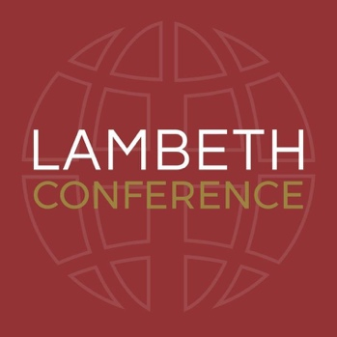
Faith and Science: Faith and science will be an important theme at this year’s conference. It is also the focus of a new Anglican Communion Science Commission, co-chaired by Archbishop Thabo Makgoba and Bishop Steven Croft. This exciting series begins to look at why the church should care about science and serves as an introduction to the work of the commission. Learn more at https://www.lambethconference.org/resources/talking-about-faith-and-science/.

Further Reading: Finally, there are several books that were written specifically about the theme of the Lambeth Conference. This is a great place to look for a book to read as an individual or study as a group within your diocese or congregation. Find these resources at https://www.lambethconference.org/resources/reading/.

