July 31, 2022 – Pentecost 8 (C)

Gifts to the Church by Episcopal Convents and Monasteries: The Order of Saint Helena

The Order of Saint Helena describes their commitment to inclusive and expansive language for worship.

What is inclusive/expansive language?
Inclusive language attempts to represent all and to respect the dignity of all human beings created in the image of God. For example:
Book of Common Prayer: “He who dwells in the shelter of the Most High….”
Saint Helena Psalter: “They who dwell in the shelter of the Most High….” (Psa. 91:1)

Book of Common Prayer: “Oh, how good and pleasant it is, when brethren live together in unity!”
Saint Helena Psalter: “Oh, how good and pleasant it is, when kindred live together in unity!” (Psa. 133:1)
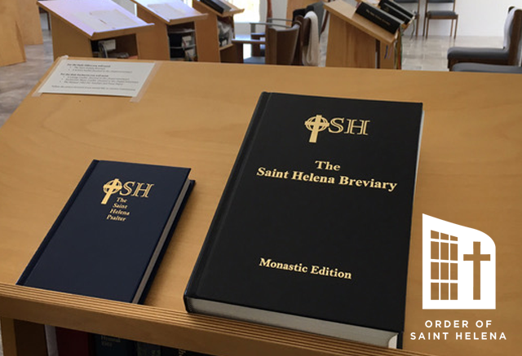
Expansive language utilizes the fullest possible expression of human language to represent the infinite being of the Divine. For example:
Book of Common Prayer: “He that planted the ear, does he not hear? He that formed the eye, does he not see?”
Saint Helena Psalter: “Does the one who planted the ear not hear; does the one who formed the eye not see?” (Psa. 94:9)

Book of Common Prayer: “The LORD is King; he has put on splendid apparel….”
Saint Helena Psalter: “God is sovereign, clothed in splendid apparel….” (Psa. 93:1a)

Why use inclusive/expansive language in worship?
Worship is a highly personal space in which we connect with God and learn of God’s all-encompassing love. Inclusive/expansive language attempts to bring human language as close as possible to describing the comprehensive presence of God and welcomes all into the community of faith.

How is the Order of Saint Helena involved in inclusive/expansive liturgy?
Since our founding in 1945, we have looked to empower women in our community and in the church. We were the first order to promote the ordination of sisters and have provided ongoing support and encouragement for women clergy in the church. Our Sr. Mary Michael was the first religious sister to be ordained.

In the 1990s, we began editing the psalter to replace male designations for God with neutral language. We attempt to stay as close as possible to the Book of Common Prayer translation and the Hebrew original, as well as to retain the beautiful cadence of the language. After editing the text, we prayed with the revised psalter for many months, and then adjusted the text over and over again. We continue to revise the Daily Office and Eucharistic prayers that we use in our chapel. We offer this work to the church in support of inclusive/expansive language for worship. For more information about The Saint Helena Psalter and The Saint Helena Breviary see www.osh.org/breviary.

