July 17, 2022 – Pentecost 6 (C)

Prayer at Lambeth

The Lambeth Conference, the international gathering of bishops across the Anglican Communion, will take place July 26 through August 8, 2022. This bulletin insert series, produced with The Episcopal Church’s Office of Global Partnerships, introduces readers to Lambeth and what they can expect from the conference.

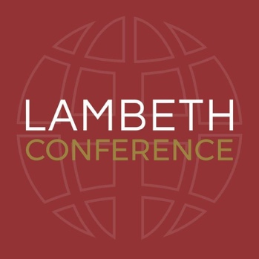
Prayer is one of the main components of the Lambeth Conference and praying together is an essential part of the gathering. Particularly in response to the COVID-19 pandemic, the climate crisis, and injustice in the world, Archbishop of Canterbury Justin Welby has invited the entire worldwide Anglican Communion to join in the Prayer Journey. In a video on the Lambeth website, he explains, “We’ll begin, as we always must, in prayer. Prayer that bring us face to face with our savior. The book of 1 Peter, in chapter four, exhorts us to be alert and of a sober mind so that we can pray, so that we can love one another deeply, and offer hospitality to one another. In such difficult times and with our world facing such challenges, we need to listen to God, to be alert to the needs of the world, and to love one another as we share our prayers and our needs.” He and his team have laid out a weekly rhythm for the prayer journey so that everyone can participate. Each day of the week you are invited to pray with a specific focus in mind: hope, proclaiming the Good News, pandemic response, people, planet, peace and reconciliation, politics and justice, and poverty.

Over the past two years, communication through online platforms has become an integral part of remaining in relationship and supporting one another. Technology has made praying together possible even when we could not be together in person. You can join along in the Archbishop’s Prayer Journey by subscribing to the email list or by following the Lambeth Conference on social media. The prayer offerings include videos from Archbishop of York Stephen Cottrell, Presiding Bishop Michael Curry, Archbishop Thabo Makgoba of Southern Africa, Archbishop Linda Nicholls of Canada, Archbishop Daniel Sarfo of Kumasi, Ghana in West Africa, Bishop Pradeep Samantaroy of Amritsar, North India, and many more. You will also receive written prayers from all over the worldwide Anglican Communion.

The videos can be found at www.lambethconference.org/resources/prayers/ and the official prayer guide for the conference can be found here: https://www.lambethconference.org/resources/prayer-guide/.

