July 10, 2022 – Pentecost 5 (C)

Scripture at Lambeth

The Lambeth Conference, the international gathering of bishops across the Anglican Communion, will take place July 26 through August 8, 2022. This bulletin insert series, produced with The Episcopal Church’s Office of Global Partnerships, introduces readers to Lambeth and what they can expect from the conference.

The theme of the fifteenth Lambeth Conference is “God’s Church for God’s World: walking, listening, and witnessing together.” As the bishops at Lambeth explore that theme, they will also maintain a Biblical focus through the book of 1 Peter. Over the past several years in planning, a range of resources have been developed for use in Bible studies, discussions, and seminars. These have been used in preparation for the conference and will be looked at on an even deeper level as the bishops gather together.

Archbishop of Canterbury Justin Welby describes why this letter was chosen as a focus for Lambeth: “The book of 1 Peter is a personal favourite of mine. There is so much in it that is pertinent for the Church, for the world, for the times we are living in and for us as we seek direction for the Anglican Communion in the years ahead.

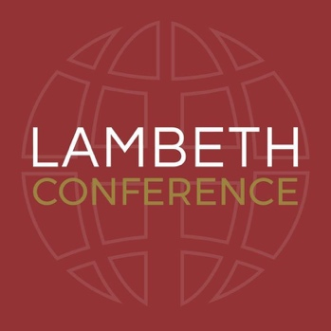
“1 Peter is a book that doesn’t shy away from difficult things. It’s a book that addresses the challenges that Peter’s communities were facing. It speaks about belonging, alienation, exile, slavery and persecution – you can immediately hear the echoes in our world today.

“It’s a book that raises an utterly compelling and inspiring vision of God’s kingdom. It raises our eyes beyond the immediacy of our struggles and differences. It urges us to hear a far deeper call. Through our faith in Jesus Christ, Peter encourages us to live lives of witness, hope and holiness as God’s chosen people.”

The journey through the book of 1 Peter looks at specific themes in each of the five chapters which include: Calling, Communion, Peace-making, Suffering, and Authority. You and your congregation can join in reading through 1 Peter looking at each of the themes, asking together what it means to be “God’s Church for God’s World.” A series of videos and commentary was created before the Lambeth Conference was rescheduled due to the COVID19 pandemic. These videos can be found at https://www.lambethconference.org/resources/1-peter-resources/watch-the-1-peter-videos/.

