July 3, 2022 – Pentecost 4 (C)

What Is the Lambeth Conference?

The Lambeth Conference will take place July 26 through August 8, 2022. Convened by the Archbishop of Canterbury, the Most Rev. and Rt. Hon. Justin Welby, the conference is a gathering of bishops from across the worldwide Anglican Communion. Lambeth, a reference to the archbishop’s residence in London where meetings were formerly held, generally occurs every ten years, though this summer’s gathering will be the first since 2008. This year’s conference will be the fifteenth since its first meeting in 1867, and will be held in Canterbury, England, at the University of Kent and Canterbury Cathedral.

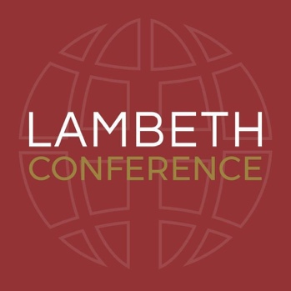
Lambeth serves as one of the four “Instruments of Communion” (along with the Archbishop himself, the Anglican Consultative Council, and the Primates’ Meeting), designed to strengthen the relationships among the member churches of the Anglican Communion. It is a time for bishops from around the world – from Texas to Minnesota to southern Virginia to Australia to South Africa to Japan to Brazil – to come together for prayer and reflection, along with fellowship and dialogue on church and world affairs.

The theme of this year’s Lambeth Conference is “God’s Church for God’s World: walking, listening, and witnessing together.” According to the Lambeth Conference website, the conference will explore what it means for the Anglican Communion to be responsive to the needs of a 21st century world. Program themes of the conference will include mission and evangelism, Safe Church, communion, reconciliation, environment and sustainable development, Christian unity, interfaith relations, and discipleship. These themes all intersect with the priority areas of The Episcopal Church.
The Most Reverend and Right Honorable Justin Welby, Archbishop of Canterbury, convener of the Lambeth Conference

Over the next three weeks, you are encouraged to read about ways to connect and be a part of the Lambeth Conference journey through scripture, prayer, and ministry resources. If you would like to learn more about the Lambeth Conference, visit www.lambethconference.org.

