August 14, 2022 – Pentecost 10 (C)

Gifts to the Church by Episcopal Convents and Monasteries:

The Community of St. Mary, Southern Province

The Community of St. Mary, Southern Province, describes their offering of guest ministry.

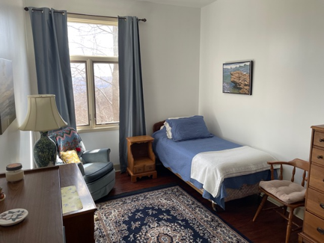
What is the guest ministry?
The term “guest ministry” refers to accommodations for visitors in religious communities. Depending on the size of a monastic house, guest accommodations can range from sections of the convent or monastery available for guests to stay in to retreat centers att ached to, or nearby, the religious community itself. A guest ministry typically involves a varying amount of contact with the nuns or monks, such as having meals with the Community or separate spaces for guests to eat. Guests are invited to attend chapel services and participate in the monastic life as much as is fitting for a Community, depending on its size and various ministries.

Why is it significant for the Church?
It is significant for the Church because it gives people a welcoming place for retreat and reflection, and a place to grow and develop in their spiritual lives. Guest ministries are havens of rest and renewal. Some places offer spiritual direction as well. This ministry gives the Church areas for stillness in the midst of the noise of their

August 14, 2022 – Pentecost 10 (C)

Gifts to the Church by Episcopal Convents and Monasteries:

The Community of St. Mary, Southern Province

The Community of St. Mary, Southern Province, describes their offering of guest ministry.

What is the guest ministry?
The term “guest ministry” refers to accommodations for visitors in religious communities. Depending on the size of a monastic house, guest accommodations can range from sections of the convent or monastery available for guests to stay in to retreat centers att ached to, or nearby, the religious community itself. A guest ministry typically involves a varying amount of contact with the nuns or monks, such as having meals with the Community or separate spaces for guests to eat. Guests are invited to attend chapel services and participate in the monastic life as much as is fitting for a Community, depending on its size and various ministries.

Why is it significant for the Church?
It is significant for the Church because it gives people a welcoming place for retreat and reflection, and a place to grow and develop in their spiritual lives. Guest ministries are havens of rest and renewal. Some places offer spiritual direction as well. This ministry gives the Church areas for stillness in the midst of the noise of their
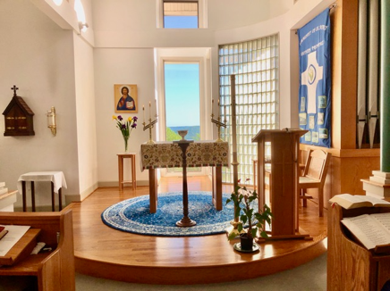
lives. One way to introduce people to the Episcopal monastic life is to have guests come and visit, spend the night, get to know the Community, and be invited into the monastic rhythm and balance of chapel services, work, silence, and rest. Staying at various Episcopal monastic communities allows people to see firsthand the impact of the Religious Life within The Episcopal Church. Visiting a convent or monastery also helps dispel a lot of myths and stereotypes people have about nuns and monks. By providing people with an experience, they can help promote and introduce others to Episcopal religious communities.

How is CSM involved in this ministry?
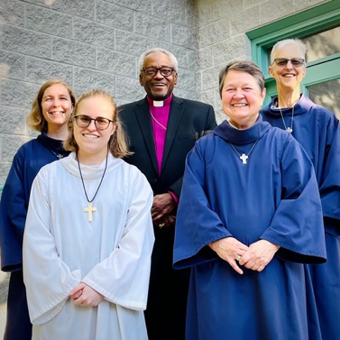
As Benedictines, hospitality is central to our way of life. St. Benedict wrote in his Rule, “All guests who present themselves are to be welcomed as Christ who said, ‘I was a stranger and you welcomed me.’” We strive to live that out by greeting the Christ in all who visit and stay at our convent. We have a variety of guest accommodations, including five rooms within our convent walls and a hermitage cabin located beside our chapel. Our hermitage cabin does not have any internet, so guests are particularly drawn to this accommodation as a time to disconnect from their social media feeds and work emails and just enjoy the silence, solitude, and space for reflection within nature. Guests who stay with us enjoy our scenic mountain views and times to slow down, be still, and discern how God is speaking to them during their stay with us.

Learn more about the Community of St. Mary, Southern Province, at https://www.communityofstmarysouth.org.
lives. One way to introduce people to the Episcopal monastic life is to have guests come and visit, spend the night, get to know the Community, and be invited into the monastic rhythm and balance of chapel services, work, silence, and rest. Staying at various Episcopal monastic communities allows people to see firsthand the impact of the Religious Life within The Episcopal Church. Visiting a convent or monastery also helps dispel a lot of myths and stereotypes people have about nuns and monks. By providing people with an experience, they can help promote and introduce others to Episcopal religious communities.

How is CSM involved in this ministry?
As Benedictines, hospitality is central to our way of life. St. Benedict wrote in his Rule, “All guests who present themselves are to be welcomed as Christ who said, ‘I was a stranger and you welcomed me.’” We strive to live that out by greeting the Christ in all who visit and stay at our convent. We have a variety of guest accommodations, including five rooms within our convent walls and a hermitage cabin located beside our chapel. Our hermitage cabin does not have any internet, so guests are particularly drawn to this accommodation as a time to disconnect from their social media feeds and work emails and just enjoy the silence, solitude, and space for reflection within nature. Guests who stay with us enjoy our scenic mountain views and times to slow down, be still, and discern how God is speaking to them during their stay with us.

Learn more about the Community of St. Mary, Southern Province, at https://www.communityofstmarysouth.org.

