September 25, 2022 – Pentecost 16 (C)

Episcopal Migration Ministries: Educational Resources
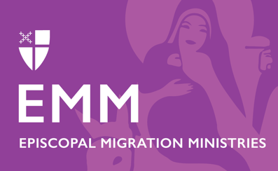
Episcopal Migration Ministries (EMM) welcome newcomers, educates communities, and advocates for humane immigration policies that respect the dignity and worth of every human being. One of the ways EMM builds welcoming communities is through educating and empowering individuals to become more engaged in migration ministry.

EMM provides resources, webinars, educational materials, and opportunities for those eager to learn more or get involved in migration ministry. Visit www.episcopalmigrationministries.com and take advantage of the following resources:
- Hometown Podcast – In its sixth season, Hometown features interviews with refugees and asylum seekers, individuals and congregations engaged in the work of welcome, experts, advocates, authors, and more.
- Book Discussion Kits – EMM provides book discussion kits to empower local congregations to learn more about immigrant individuals and communities. These kits are rich in resources and questions to get your discussion going.
- Study & Worship – EMM offers seasonal liturgy resources for Advent, Epiphany, Lent, and World Refugee Day.
- Refugee Sunday Toolkit – This comprehensive toolkit guides congregations through the process of planning and hosting a Refugee Sunday.
- Supporting Asylum Seekers Toolkit – This toolkit provides guidance and resources for congregations who want to support asylum seekers and welcome their newest neighbors.
- Weekly News Digest and Monthly Newsletter – Sign up to receive a weekly immigration news digest and monthly EMM Friends & Supporters Newsletter.

Ways to Support Episcopal Migration Ministries

DONATE
Your gift helps makes this life-changing ministry possible. To make your tax-deductible donation today:
Text “Give” to 41444 or Call (212) 716-6002 to give over the phone.
Give online by visiting bit.ly/supportemm or scanning this QR code.

Send your gift by check or money order to:
DFMS-Protestant Episcopal Church US
P.O. Box 958983
St. Louis, MO 63195-8983

VOLUNTEER or SPONSOR
Volunteer at your local resettlement office or become a community sponsor. Learn more about these opportunities at episcopalmigrationministries.org.

EDUCATE
Explore EMM’s resources, opportunities, newsletters, webinars, Hometown podcast, blog posts, and more at episcopalmigrationminsitries.org.

PRAY
Please include Episcopal Migration Ministries regularly in your prayers. Refugee resettlement ministry includes professional staff, but also tens of thousands of volunteers, congregations, and community partners and stakeholders, who all come together to welcome and support our new neighbor.

