September 11, 2022 – Pentecost 14 (C)

Episcopal Migration Ministries: Ministry Network

This month, our friends at Episcopal Migration Ministries share the many facets of their work with refugees and other forcibly displaced people.

Episcopal Migration Ministries (EMM), the refugee resettlement and migration ministry of The Episcopal Church, is also the Church’s convening place for collaboration, education, and information-sharing on migration.

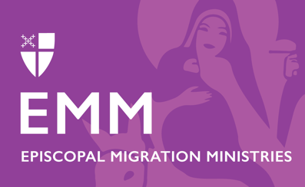
EMM convenes an Episcopal Asylum & Detention Ministry Network that meets virtually on the fourth Wednesday of every month. The Ministry Network’s collaborative work and conversation focus on best practice-sharing in areas of direct service, organizing, advocacy actions, Christian formation and worship resources, and community education to protect asylum, promote humane and dignified alternatives to detention, and to support asylum seekers and those harmed by the immigration detention system.

Learn more and register to attend meetings at episcopalmigrationministries.org/ministrynetwork.

Ways to Support Episcopal Migration Ministries

DONATE
Your gift helps makes this life-changing ministry possible. To make your tax-deductible donation today:
Text “Give” to 41444 or Call (212) 716-6002 to give over the phone.
Give online by visiting bit.ly/supportemm or scanning this QR code.

Send your gift by check or money order to:
DFMS-Protestant Episcopal Church US
P.O. Box 958983
St. Louis, MO 63195-8983

VOLUNTEER or SPONSOR
Volunteer at your local resettlement office or become a community sponsor. Learn more about these opportunities at episcopalmigrationministries.org.

EDUCATE
Explore EMM’s resources, opportunities, newsletters, webinars, Hometown podcast, blog posts, and more at episcopalmigrationminsitries.org.

PRAY
Please include Episcopal Migration Ministries regularly in your prayers. Refugee resettlement ministry includes professional staff, but also tens of thousands of volunteers, congregations, and community partners and stakeholders, who all come together to welcome and support our new neighbors.

