September 4, 2022 – Pentecost 13 (C)

Episcopal Migration Ministries: Resettlement

This month, our friends at Episcopal Migration Ministries share the many facets of their work with refugees and other forcibly displaced people.

There are over 89.3 million people forcibly displaced in the world today, the highest level ever recorded. 21.3 million are refugees. Over half of all refugees are children.

Episcopal Migration Ministries (EMM) is The Episcopal Church’s foremost response to this refugee crisis, welcoming thousands of refugees to the United States each year. These children, women, and men have fled unimaginable horrors - persecution, war, and violence. With Episcopal Migration Ministries’ help, they rebuild their lives in the United States, becoming our neighbors and contributing members of our communities.

Since the 1980s, EMM has resettled over 100,000 individuals through a network of local affiliates who provide refugees with the items and the resettlement services they’ll need during their first thirty days in the U.S., including housing, food, furnishings, and orientation to life in their new communities. EMM affiliates also connect newcomers to services like English classes and job training, while helping them access health care, enroll their children in school and understand the other services available in the community.
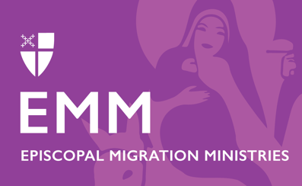
All resettlement is local, community-building work. Our local partners coordinate with a wide range of stakeholders, including service providers, local government officials, school districts, churches, volunteers, and many others to provide a positive resettlement experience for refugees and their new neighbors.

No matter who you are, you have gifts and talents you can use to welcome your newest neighbors.

Ways to Support Episcopal Migration Ministries

DONATE
Your gift helps makes this life-changing ministry possible. To make your tax-deductible donation today:
Text “Give” to 41444 or Call (212) 716-6002 to give over the phone.
Give online by visiting bit.ly/supportemm or scanning this QR code.

Send your gift by check or money order to:
DFMS-Protestant Episcopal Church US
P.O. Box 958983
St. Louis, MO 63195-8983

VOLUNTEER or SPONSOR
Volunteer at your local resettlement office or become a community sponsor. Learn more about these opportunities at episcopalmigrationministries.org.

EDUCATE
Explore EMM’s resources, opportunities, newsletters, webinars, Hometown podcast, blog posts, and more at episcopalmigrationminsitries.org.

PRAY
Please include Episcopal Migration Ministries regularly in your prayers. Refugee resettlement ministry includes professional staff, but also tens of thousands of volunteers, congregations, and community partners and stakeholders, who all come together to welcome and support our new neighbors.

