November 13, 2022 – Pentecost 23 (C)

AdventWord

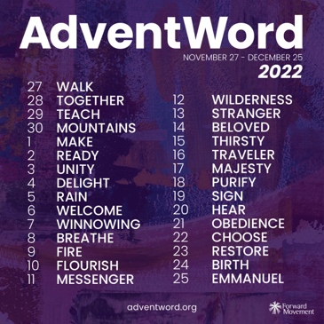
Forward Movement has announced the 2022 reflection words for AdventWord, a global online advent calendar and community of disciples. For nearly a decade AdventWord has inspired followers of Jesus who wish to add an accessible prayer practice to their daily routine during this holy season.
Daily meditations and images—inspired by a prompt word selected from the daily lectionary readings—will be released at adventword.org, beginning Sunday, November 27.
Participants can sign up to receive this daily message, in English and Spanish, by email or by following AdventWord on social media.
Many followers join the creativity each year by sharing their own personal reflections across social media using #AdventWord. Participants respond with photos, written responses, crafts, drawings, poems, found art, and other creative expressions inspired by the day’s selected word.
“This year we enlisted volunteer community members to help with the selection of prompt words from the daily lectionary readings,” said Richelle Thompson, managing editor at Forward Movement. “The online gathering of dozens of AdventWord community members was an inspiring way to kick off the planning for 2022 and a strong reminder that AdventWord is community-driven.”

The prompts for 2022 #AdventWord are:

November 27 - Walk
November 28 - Together
November 29 - Teach
November 30 - Mountains
December 1 - Make
December 2 - Ready
December 3 - Unity
December 4 - Delight
December 5 - Rain
December 6 - Welcome
December 7 - Winnowing
December 8 - Breathe
December 9 - Fire
December 10 - Flourish
December 11 - Messenger
December 12 - Wilderness
December 13 - Stranger
December 14 - Beloved
December 15 - Thirsty
December 16 - Traveler
December 17 - Majesty
December 18 - Purify
December 19 - Sign
December 20 - Hear
December 21 - Obedience
December 22 - Choose
December 23 - Restore
December 24 - Birth
December 25 - Emmanuel

The #AdventWord Images and meditations can be experienced through AdventWord.org, direct daily emails, as well as on Facebook, Instagram, and Twitter. Meditations will also be available on www.adventword.org.

