November 13, 2022 – Pentecost 23 (C)

AdventWord

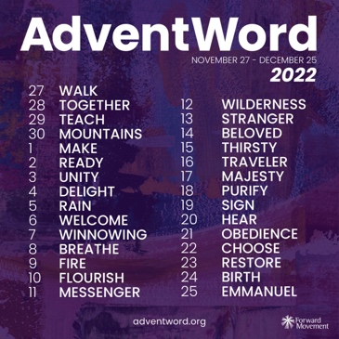
Forward Movement has announced the 2022 reflection words for AdventWord, a global online advent calendar and community of disciples. For nearly a decade AdventWord has inspired followers of Jesus who wish to add an accessible prayer practice to their daily routine during this holy season.
Daily meditations and images—inspired by a prompt word selected from the daily lectionary readings—will be released at adventword.org, beginning Sunday, November 27.
Participants can sign up to receive this daily message, in English and Spanish, by email or by following AdventWord on social media.
Many followers join the creativity each year by sharing their own personal reflections across social media using #AdventWord. Participants respond with photos, written responses, crafts, drawings,

November 13, 2022 – Pentecost 23 (C)

AdventWord

Forward Movement has announced the 2022 reflection words for AdventWord, a global online advent calendar and community of disciples. For nearly a decade AdventWord has inspired followers of Jesus who wish to add an accessible prayer practice to their daily routine during this holy season.
Daily meditations and images—inspired by a prompt word selected from the daily lectionary readings—will be released at adventword.org, beginning Sunday, November 27.
Participants can sign up to receive this daily message, in English and Spanish, by email or by following AdventWord on social media.
Many followers join the creativity each year by sharing their own personal reflections across social media using #AdventWord. Participants respond with photos, written responses, crafts, drawings,

poems, found art, and other creative expressions inspired by the day’s selected word.
“This year we enlisted volunteer community members to help with the selection of prompt words from the daily lectionary readings,” said Richelle Thompson, managing editor at Forward Movement. “The online gathering of dozens of AdventWord community members was an inspiring way to kick off the planning for 2022 and a strong reminder that AdventWord is community-driven.”

The prompts for 2022 #AdventWord are:
November 27 - Walk December 12 - Wilderness
November 28 - Together December 13 - Stranger
November 29 - Teach December 14 - Beloved
November 30 - Mountains December 15 - Thirsty
December 1 - Make December 16 - Traveler
December 2 - Ready December 17 - Majesty
December 3 - Unity December 18 - Purify
December 4 - Delight December 19 - Sign
December 5 - Rain December 20 - Hear
December 6 - Welcome December 21 - Obedience
December 7 - Winnowing December 22 - Choose
December 8 - Breathe December 23 - Restore
December 9 - Fire December 24 - Birth
December 10 - Flourish December 25 - Emmanuel
December 11 - Messenger

The #AdventWord Images and meditations can be experienced through AdventWord.org, direct daily emails, as well as on Facebook, Instagram, and Twitter. Meditations will also be available on www.adventword.org.
poems, found art, and other creative expressions inspired by the day’s selected word.
“This year we enlisted volunteer community members to help with the selection of prompt words from the daily lectionary readings,” said Richelle Thompson, managing editor at Forward Movement. “The online gathering of dozens of AdventWord community members was an inspiring way to kick off the planning for 2022 and a strong reminder that AdventWord is community-driven.”

The prompts for 2022 #AdventWord are:
November 27 - Walk December 12 - Wilderness
November 28 - Together December 13 - Stranger
November 29 - Teach December 14 - Beloved
November 30 - Mountains December 15 - Thirsty
December 1 - Make December 16 - Traveler
December 2 - Ready December 17 - Majesty
December 3 - Unity December 18 - Purify
December 4 - Delight December 19 - Sign
December 5 - Rain December 20 - Hear
December 6 - Welcome December 21 - Obedience
December 7 - Winnowing December 22 - Choose
December 8 - Breathe December 23 - Restore
December 9 - Fire December 24 - Birth
December 10 - Flourish December 25 - Emmanuel
December 11 - Messenger

The #AdventWord Images and meditations can be experienced through AdventWord.org, direct daily emails, as well as on Facebook, Instagram, and Twitter. Meditations will also be available on www.adventword.org.

