November 20, 2022 – Christ the King (C)

Christ the King Sunday
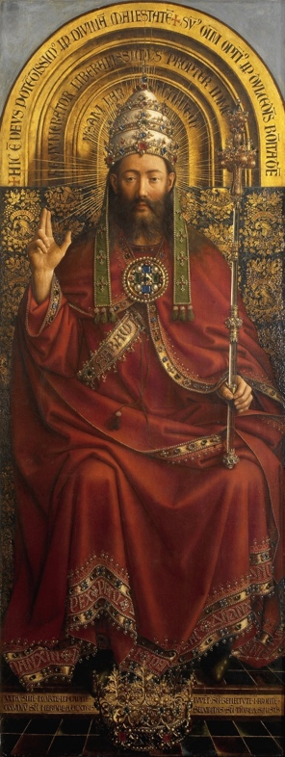
Today, many parishes within The Episcopal Church celebrate the Feast of Christ the King. This feast day falls on the last Sunday of the liturgical year, the Sunday before the beginning of Advent. The feast is a relative newcomer to the liturgical calendar; it was first instituted by Pope Pius XI in 1925, when he wrote the encyclical Quas Primas. Here, he lays out the different understandings of kingship that Jesus Christ possesses.

Pius XI also explains how Christians ought to live as a result of Christ’s kingship: “He must reign in our minds, which should assent with perfect submission and firm belief to revealed truths and to the doctrines of Christ. He must reign in our wills, which should obey the laws and precepts of God. He must reign in our hearts, which should spurn natural desires and love God above all things, and cleave to him alone. He must reign in our bodies and in our members, which should serve as instruments for the interior sanctification of our souls, or to use the words of the Apostle Paul, as instruments of justice unto God.” By the 1970s, the Feast of Christ the King had been more or less institutionalized throughout many Christian denominations and was fixed as occurring the last Sunday before Advent.

The lessons for this day support the understanding of Christ as sovereign. Jeremiah writes, “The days are surely coming, says the Lord, when I will raise up for David a righteous Branch, and he shall reign as king and deal wisely, and shall execute justice and righteousness in the land.” The Song of Zechariah bridges the seasons beautifully as we hear the prophecy foretelling the ministry of St. John the Baptist, from whom we’ll hear more very shortly. The Letter to the Colossians explains, “[The Father] has rescued us from the power of darkness and transferred us into the kingdom of his beloved Son, in whom we have redemption, the forgiveness of sins.” It is only in the Gospel reading that we see the most difficult aspect of Jesus’ kingship: “The soldiers also mocked him, coming up and offering him sour wine, and saying, ‘If you are the King of the Jews, save yourself!’ There was also an inscription over him, ‘This is the King of the Jews.’” We remember that Jesus’ kingship is not distant and remote in some capital city thousands of miles away. His kingship is not detached nor aloof. No, he reigns for now in the very hearts of the faithful, freeing us and bringing us together under his most gracious rule.

Collect for the Feast of Christ the King
Almighty and everlasting God, whose will it is to restore all things in your well-beloved Son, the King of kings and Lord of lords: Mercifully grant that the peoples of the earth, divided and enslaved by sin, may be freed and brought together under his most gracious rule; who lives and reigns with you and the Holy Spirit, one God, now and for ever. Amen (BCP 236).

