October 23, 2022 – Pentecost 20 (C)

Meet Episcopal Volunteers in Mission: Peter Bak

Hello, I’m Peter Bak, a missionary with Episcopal Volunteers in Mission (EVIM), serving part of each year in Tanzania. I was finally able to return to St. Philip’s Theological College earlier this year. My last visit was back in early 2020 and, while I’ve been staying in touch virtually, it was so good to be back in-person. My parish has been supporting two students in their studies and I was able to be present for their graduation. I enjoyed getting back to work with Goodluck and Gracewell on some painting and building projects – and dealing with a big tree that fell onto the roof of one of our buildings during a storm. More than anything, it’s been good to be back with friends and this wonderful community.

I chose to serve as an Episcopal Volunteer in Mission because I wanted to give back. Throughout my life, people have supported me in many different ways, and I wanted to share that gift with others. The first time I thought about being a missionary was when I was doing hospice visits back home in Rhode Island. I was able to train the first pitbull to serve in hospice in Rhode Island.

October 23, 2022 – Pentecost 20 (C)

Meet Episcopal Volunteers in Mission: Peter Bak

Hello, I’m Peter Bak, a missionary with Episcopal Volunteers in Mission (EVIM), serving part of each year in Tanzania. I was finally able to return to St. Philip’s Theological College earlier this year. My last visit was back in early 2020 and, while I’ve been staying in touch virtually, it was so good to be back in-person. My parish has been supporting two students in their studies and I was able to be present for their graduation. I enjoyed getting back to work with Goodluck and Gracewell on some painting and building projects – and dealing with a big tree that fell onto the roof of one of our buildings during a storm. More than anything, it’s been good to be back with friends and this wonderful community.

I chose to serve as an Episcopal Volunteer in Mission because I wanted to give back. Throughout my life, people have supported me in many different ways, and I wanted to share that gift with others. The first time I thought about being a missionary was when I was doing hospice visits back home in Rhode Island. I was able to train the first pitbull to serve in hospice in Rhode Island.

Her name was Lucy and when I saw the affection shared between the clients and Lucy, I was filled with joy. Each time I was able to put a smile on someone’s face, it felt fantastic. I wanted to serve as a missionary because I believed that it could also bring me that joy and offer me an opportunity to build relationships outside of what I have always known.

Like many ministries in the Church, there are many more needs than physical resources. That is why I quite often turn to prayer, asking for ideas about how to do a job with less. On my last visit, I took lots of pictures that capture the spirit of the seminary community and offer a glimpse of what I see daily when I’m in Tanzania. You can follow me on my blog: petergoestotanzania.wordpress.com.

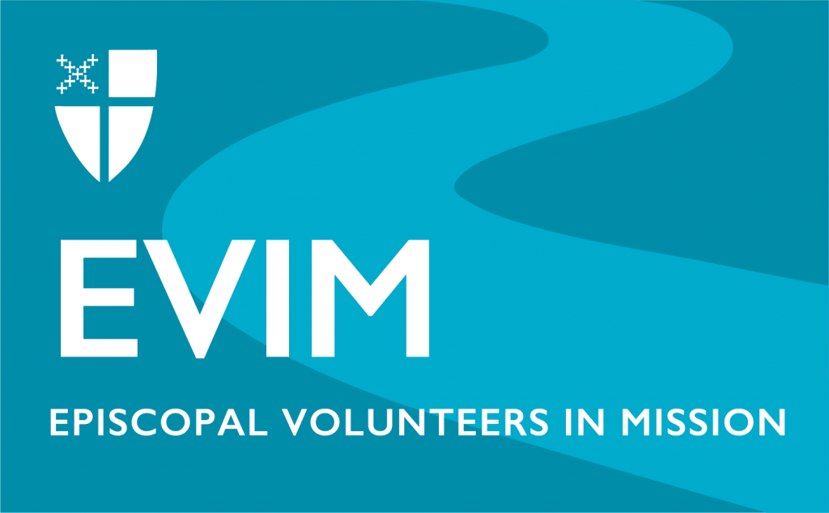
Open to Episcopalians ages 30+, Episcopal Volunteers in Mission invites you to build relationships, share your gifts and skills, listen to and learn from partners around the world, and be open to the personal transformation that comes from meeting God in new ways. Missionaries are lay and ordained, young and old. They serve as teachers, accountants, doctors, administrators, theologians, agriculturalists, chaplains, and much more. Learn more at iam.ec/evim.

Her name was Lucy and when I saw the affection shared between the clients and Lucy, I was filled with joy. Each time I was able to put a smile on someone’s face, it felt fantastic. I wanted to serve as a missionary because I believed that it could also bring me that joy and offer me an opportunity to build relationships outside of what I have always known.

Like many ministries in the Church, there are many more needs than physical resources. That is why I quite often turn to prayer, asking for ideas about how to do a job with less. On my last visit, I took lots of pictures that capture the spirit of the seminary community and offer a glimpse of what I see daily when I’m in Tanzania. You can follow me on my blog: petergoestotanzania.wordpress.com.

Open to Episcopalians ages 30+, Episcopal Volunteers in Mission invites you to build relationships, share your gifts and skills, listen to and learn from partners around the world, and be open to the personal transformation that comes from meeting God in new ways. Missionaries are lay and ordained, young and old. They serve as teachers, accountants, doctors, administrators, theologians, agriculturalists, chaplains, and much more. Learn more at iam.ec/evim.

