October 30, 2022 – Pentecost 21 (C)

Meet the Young Adult Service Corps: Madeline Hennig

My name is Madeline Hennig from the Diocese of Spokane and originally from Coeur d’Alene, Idaho. I am a Young Adult Service Corps (YASC) missionary serving in Rome at St. Paul’s Within the Walls and its ministry the Joel Nafuma Refugee Center. In May 2021, I graduated from George Washington University with degrees in International Business and International Affairs, so serving in Rome doing refugee work has given me interesting experiences for my career and faith journey. St. Paul’s is coming up on its 150th anniversary as a non-Catholic parish and community historically for American expats and Italians. Now, the community has turned into a vibrant multicultural group including parishioners from Africa, Latin America, and Europe.

I applied for YASC last year because I was looking for a way to volunteer with a service program before going into the workforce. I have been an Episcopalian for my entire life and my church life has always been important to me. As a youth, I participated in the Episcopal Youth Event twice and was involved at Camp Cross in Coeur d’Alene. Sharing my church life with like-minded people has been so important for my mental health and well-being. I knew that YASC would provide me a similar opportunity at an international location with other Episcopalians and Anglicans.

I also knew I wanted to live abroad after graduating university, so this would be a great way to get started. So far, I’ve learned a whole new aspect of The Episcopal Church, which is the churches here in Europe. The dynamics are quite different than they are in the United States. I also am witnessing what it is like to see a church evolve. St. Paul’s has many different cultures, and we are fully embracing it. I have loved being here and contributing to the different ministries and fellowship that St. Paul’s has to offer here in Rome.

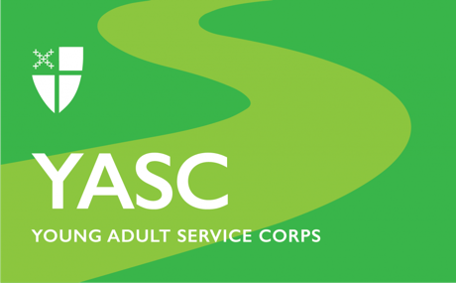

The Young Adult Service Corps is a ministry for Episcopalians ages 21-30 who are interested in exploring their faith in new ways by living and serving in communities around the worldwide Anglican Communion. Learn more at iam.ec/YASC.

