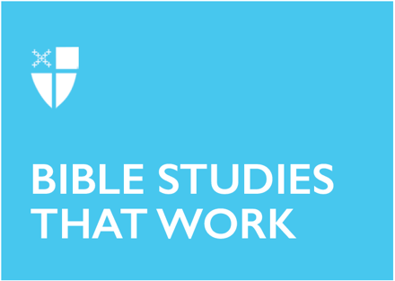
Epiphany 2 (A)
January 15, 2023

[RCL] Isaiah 49:1-7; Psalm 40:1-12; 1 Corinthians 1:1-9; John 1:29-42

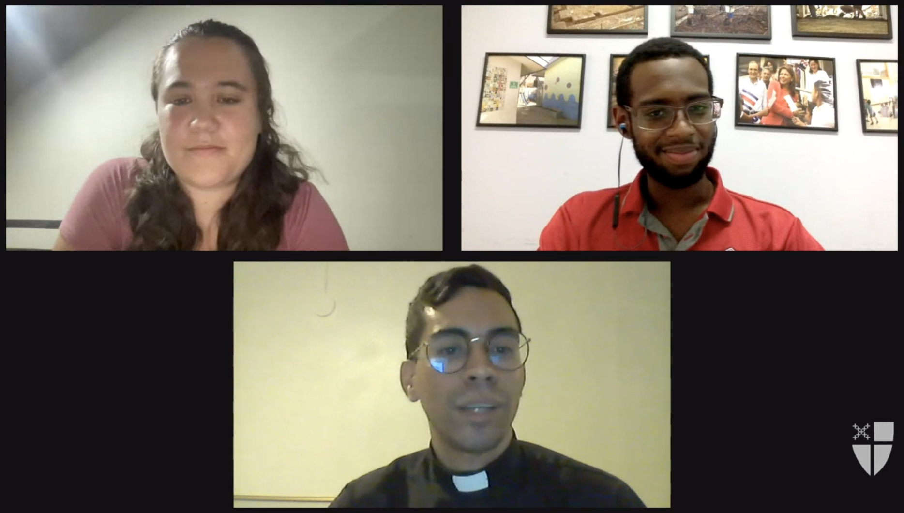
The season of Epiphany is when we celebrate the revealing of Christ to the world. We mark the arrival of the One who is the light of the world: a light that brings life, a light that brings hope. This light shines its brightest when we are in community - with God and with one another. The Office of Global Partnerships of The Episcopal Church invites individuals, small groups, congregations, and dioceses to use our weekly video series throughout the season of Epiphany to draw closer to each other and our Lord. Using an adaptation of lectio divina with the gospel passage for each Sunday, you’ll meet and hear from Episcopal missionaries who have served around the world as they read and reflect on Jesus’ revelation to us. Missionary service through The Episcopal Church is accomplished through the Young Adult Service Corps (for Episcopalians aged 21-30) and Episcopal Volunteers in Mission (for Episcopalians over the age of 30). Learn more about these programs at iam.ec/yasc and iam.ec/evim respectively.

This week’s lectio divina features Sophie Swallow, Andrew Walker, and the Rev. Bryan Vélez. Watch their discussion, recorded in Spanish first, at iam.ec/epiphany2023 and follow along by yourself or in a small group. To participate:

1. Read today’s Gospel passage: John saw Jesus coming toward him and declared, “Here is the Lamb of God who takes away the sin of the world! This is he of whom I said, ‘After me comes a man who ranks ahead of me because he was before me.’ I myself did not know him; but I came baptizing with water for this reason, that he might be revealed to Israel.” And John testified, “I saw the Spirit descending from heaven like a dove, and it remained on him. I myself did not know him, but the one who sent me to baptize with water said to me, ‘He on whom you see the Spirit descend and remain is the one who baptizes with the Holy Spirit.’ And I myself have seen and have testified that this is the Son of God.” The next day John again was standing with two of his disciples, and as he watched Jesus walk by, he exclaimed, “Look, here is the Lamb of God!” The two disciples heard him say this, and they followed Jesus. When Jesus turned and saw them following, he said to them, “What are you looking for?” They said to him, “Rabbi” (which translated means Teacher), “where are you staying?” He said to them, “Come and see.” They came and saw where he was staying, and they remained with him that day. It was about four o’clock in the afternoon. One of the two who heard John speak and followed him was Andrew, Simon Peter’s brother. He first found his brother Simon and said to him, “We have found the Messiah” (which is translated Anointed). He brought Simon to Jesus, who looked at him and said, “You are Simon son of John. You are to be called Cephas” (which is translated Peter). (John 1:29-42, NRSV)

2. Reflect: Which word or short phrase caught your attention or came to mind? Whether you’re alone or in a group, say it aloud.

3. Read: Reread the passage, perhaps in a different translation.

4. Reflect: Where does the passage touch your life today? If you’re with a group, share your responses with each other, without discussing further. If you’re alone, say your response aloud or write it down.

5. Read: Reread the passage, perhaps in yet another translation.

6. Reflect: Where is God calling you to go? Where, either near or far, can you cross boundaries, listen deeply, and live like Jesus? You might consider journaling out your response and meditating on it over the course of this week.

7. Pray: In closing, say the Collect for Epiphany 2 in the Book of Common Prayer (p. 215).

