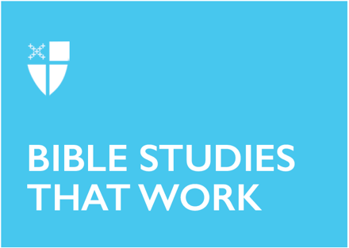
Epiphany 3 (A)
January 22, 2023

[RCL] Isaiah 9:1-4; Psalm 27:1, 5-13; 1 Corinthians 1:10-18; Matthew 4:12-23

The season of Epiphany is when we celebrate the revealing of Christ to the world. We mark the arrival of the One who is the light of the world: a light that brings life, a light that brings hope. This light shines its brightest when we are in community - with God and with one another.

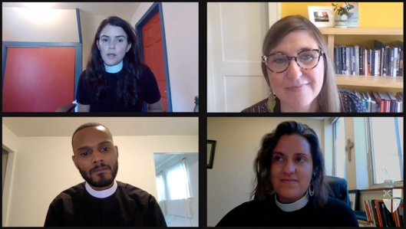
The Office of Global Partnerships of The Episcopal Church invites individuals, small groups, congregations, and dioceses to use our weekly video series throughout the season of Epiphany to draw closer to each other and our Lord. Using an adaptation of lectio divina with the gospel passage for each Sunday, you’ll meet and hear from Episcopal missionaries who have served around the world as they read and reflect on Jesus’ revelation to us. Missionary service through The Episcopal Church is accomplished through the Young Adult Service Corps (for Episcopalians aged 21-30) and Episcopal Volunteers in Mission (for Episcopalians over the age of 30). Learn more about these programs at iam.ec/yasc and iam.ec/evim respectively.

This week’s lectio divina features the Rev. Natalie Thomas, the Rev. Melanie Slane, the Rev. Paul Daniels, and Erin Weber-Johnson. Watch their discussion at iam.ec/epiphany2023 and follow along by yourself or in a small group. To participate:

1. Read today’s Gospel passage: When Jesus heard that John had been arrested, he withdrew to Galilee. He left Nazareth and made his home in Capernaum by the sea, in the territory of Zebulun and Naphtali, so that what had been spoken through the prophet Isaiah might be fulfilled: “Land of Zebulun, land of Naphtali, on the road by the sea, across the Jordan, Galilee of the Gentiles—the people who sat in darkness have seen a great light, and for those who sat in the region and shadow of death light has dawned.” From that time Jesus began to proclaim, “Repent, for the kingdom of heaven has come near.” As he walked by the Sea of Galilee, he saw two brothers, Simon, who is called Peter, and Andrew his brother, casting a net into the sea—for they were fishermen. And he said to them, “Follow me, and I will make you fish for people.” Immediately they left their nets and followed him. As he went from there, he saw two other brothers, James son of Zebedee and his brother John, in the boat with their father Zebedee, mending their nets, and he called them. Immediately they left the boat and their father, and followed him. Jesus went throughout Galilee, teaching in their synagogues and proclaiming the good news of the kingdom and curing every disease and every sickness among the people. (Matthew 4:12-23, NRSV)
2. Reflect: Which word or short phrase caught your attention or came to mind? Whether you’re alone or in a group, say it aloud.

3. Read: Reread the passage, perhaps in a different translation.

4. Reflect: Where does the passage touch your life today? If you’re with a group, share your responses with each other, without discussing further. If you’re alone, say your response aloud or write it down.

5. Read: Reread the passage, perhaps in yet another translation.

6. Reflect: Where is God calling you to go? Where, either near or far, can you cross boundaries, listen deeply, and live like Jesus? You might consider journaling out your response and meditating on it over the course of this week.

7. Pray: In closing, say the Collect for Epiphany 3 in the Book of Common Prayer (p. 215).

