January 30, 2023 – Epiphany 4 (A)
Episcopal Service Corps: Empowering Young Leaders for Justice

For more than 20 years, Episcopal Service Corps (ESC) has been built on the belief that change happens when we bring together diverse teams of committed and passionate young leaders and support them as they tackle some of our nation’s most difficult challenges.

ESC empowers young adults, ages 21-32, to transform themselves and the unjust structures that surround us all through community building, local collaboration, prayer, and action.

Joining Episcopal Service Corps means joining a community of people who care about each person as an individual. We invest in knowing each member’s hopes, dreams, challenges, and giftedness, and are dedicated to creating spaces of belonging where each person is accepted for their authentic self.

What to Expect
Community-building: Community is at the heart of ESC. It means commiting to coming together regularly to eat, pray, laugh, cry, and practice the type of reconciliation and forgiveness that only happens when we live in proximity.

January 30, 2023 – Epiphany 4 (A)
Episcopal Service Corps: Empowering Young Leaders for Justice

For more than 20 years, Episcopal Service Corps (ESC) has been built on the belief that change happens when we bring together diverse teams of committed and passionate young leaders and support them as they tackle some of our nation’s most difficult challenges.

ESC empowers young adults, ages 21-32, to transform themselves and the unjust structures that surround us all through community building, local collaboration, prayer, and action.

Joining Episcopal Service Corps means joining a community of people who care about each person as an individual. We invest in knowing each member’s hopes, dreams, challenges, and giftedness, and are dedicated to creating spaces of belonging where each person is accepted for their authentic self.

What to Expect
Community-building: Community is at the heart of ESC. It means commiting to coming together regularly to eat, pray, laugh, cry, and practice the type of reconciliation and forgiveness that only happens when we live in proximity.

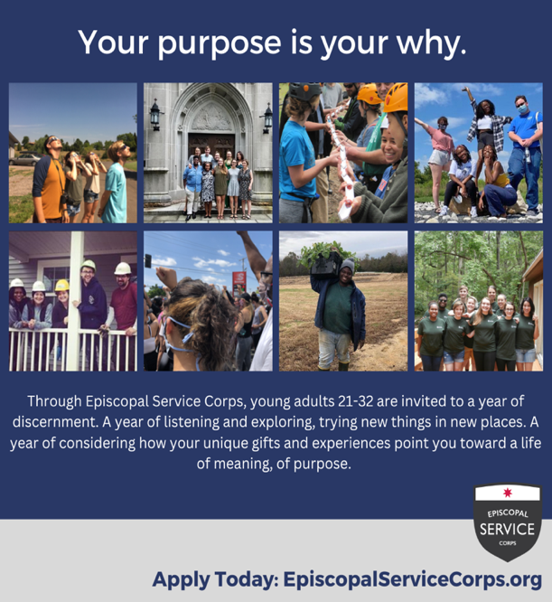
Spiritual and Vocational Discernment: Every program offers formation days to pray, check-in, and discuss topics ranging from theology to vocational planning to social justice.

Justice-Making: Every corps deploys by volunteering through local placement sites for at least 32 hours per week. From farming to immigrant outreach and from ministry to community organizing, these opportunities place members in the heart of the community and offer experiential immersion, focused on honing professional skill development and moving forward social justice initiatives.

In Episcopal Service Corps, we do our very best to ensure our corps have structures behind them for a successful year. To that end, every member receives housing, utilities, health coverage, access to mental health resources, as well as small stipends to cover living expenses, transportation, and food.

The ESC application for the 2023-2024 program year is now open and can be found on our website, EpiscopalServiceCorps.org. Questions? Contact Wendy Johnson at esc@episcopalchurch.org.

Spiritual and Vocational Discernment: Every program offers formation days to pray, check-in, and discuss topics ranging from theology to vocational planning to social justice.

Justice-Making: Every corps deploys by volunteering through local placement sites for at least 32 hours per week. From farming to immigrant outreach and from ministry to community organizing, these opportunities place members in the heart of the community and offer experiential immersion, focused on honing professional skill development and moving forward social justice initiatives.

In Episcopal Service Corps, we do our very best to ensure our corps have structures behind them for a successful year. To that end, every member receives housing, utilities, health coverage, access to mental health resources, as well as small stipends to cover living expenses, transportation, and food.

The ESC application for the 2023-2024 program year is now open and can be found on our website, EpiscopalServiceCorps.org. Questions? Contact Wendy Johnson at esc@episcopalchurch.org.

