January 15, 2023 – Epiphany 2 (A)
Getting Connected: Young Adult and Campus Ministry

Whoever welcomes one such child in my name welcomes me. - Matthew 18:5

If you are a young adult who is looking for community and relationship as you explore your faith and way in life, the Office of Young Adult and Campus Ministries wants to help you find a connection to a ministry, chaplaincy, local clergy person, congregation, group, leader, or organizer.

The Office of Young Adult and Campus Ministries, along with the Young Adult and Campus Ministries Council of Advice, works together to help young adults find new communities and connect with individuals wherever they are in The Episcopal Church. We know that finding a community can be a daunting and overwhelming task, so we want to help in any way that we can.

We have a couple of ways to get you connected to a new ministry when you move or progress from being a youth to a young adult.

The first option is to check out the Episcopal Asset Map that is being updated and maintained by ministries

January 15, 2023 – Epiphany 2 (A)
Getting Connected: Young Adult and Campus Ministry

Whoever welcomes one such child in my name welcomes me. - Matthew 18:5

If you are a young adult who is looking for community and relationship as you explore your faith and way in life, the Office of Young Adult and Campus Ministries wants to help you find a connection to a ministry, chaplaincy, local clergy person, congregation, group, leader, or organizer.

The Office of Young Adult and Campus Ministries, along with the Young Adult and Campus Ministries Council of Advice, works together to help young adults find new communities and connect with individuals wherever they are in The Episcopal Church. We know that finding a community can be a daunting and overwhelming task, so we want to help in any way that we can.

We have a couple of ways to get you connected to a new ministry when you move or progress from being a youth to a young adult.

The first option is to check out the Episcopal Asset Map that is being updated and maintained by ministries

themselves. Visit this link to search your area and see what is going on: https://iam.ec/yacmmap. The Young Adult and Campus Ministries Network map has some but not all of our ministries represented; if your ministry is not on here, please submit information!

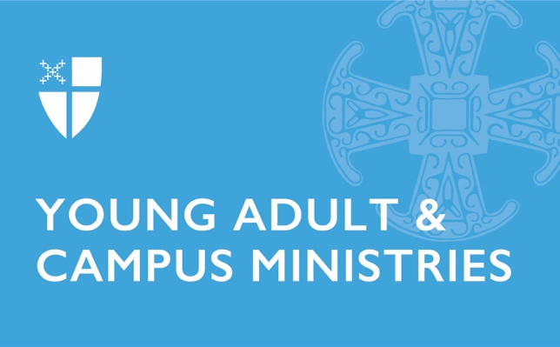
Secondly, you can fill out a Young Adult Referral Form. This can be filled out by the young adult or a mentor, parent, or clergy person who is seeking to help them find a ministry. Once you submit this form, we will do our best to connect you to a congregation, young adult ministry, campus ministry, or other kinds of ministry near you. When we receive your request, the Officer for Young Adult and Campus Ministries and the Council of Advice reach out to local ministries and find the best possible connection for the young adult. Find the form here: https://iam.ec/yareferrals.

If you have questions, please contact the Rev. Shannon Kelly, Director of the Department of Faith Formation and Officer for Young Adult and Campus Ministries, at skelly@episcopalchurch.org.

themselves. Visit this link to search your area and see what is going on: https://iam.ec/yacmmap. The Young Adult and Campus Ministries Network map has some but not all of our ministries represented; if your ministry is not on here, please submit information!

Secondly, you can fill out a Young Adult Referral Form. This can be filled out by the young adult or a mentor, parent, or clergy person who is seeking to help them find a ministry. Once you submit this form, we will do our best to connect you to a congregation, young adult ministry, campus ministry, or other kinds of ministry near you. When we receive your request, the Officer for Young Adult and Campus Ministries and the Council of Advice reach out to local ministries and find the best possible connection for the young adult. Find the form here: https://iam.ec/yareferrals.

If you have questions, please contact the Rev. Shannon Kelly, Director of the Department of Faith Formation and Officer for Young Adult and Campus Ministries, at skelly@episcopalchurch.org.

