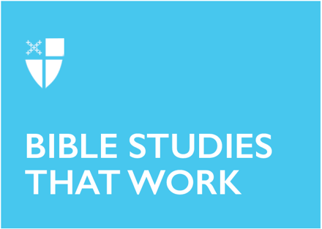
Epiphany 4 (A)
January 29, 2023

[RCL] Micah 6:1-8; Psalm 15; 1 Corinthians 1:18-31; Matthew 5:1-12

The season of Epiphany is when we celebrate the revealing of Christ to the world. We mark the arrival of the One who is the light of the world: a light that brings life, a light that brings hope. This light shines its brightest when we are in community - with God and with one another.
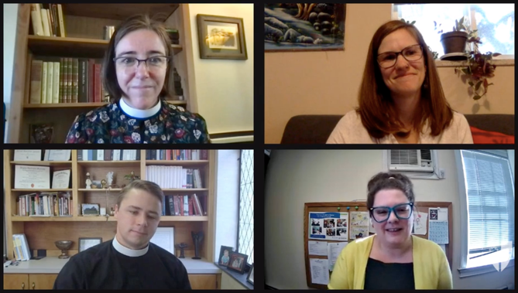
The Office of Global Partnerships of The Episcopal Church invites individuals, small groups, congregations, and dioceses to use our weekly video series throughout the season of Epiphany to draw closer to each other and our Lord. Using an adaptation of lectio divina with the gospel passage for each Sunday, you’ll meet and hear from Episcopal missionaries who have served around the world as they read and reflect on Jesus’ revelation to us. Missionary service through The Episcopal Church is accomplished through the Young Adult Service Corps (for Episcopalians aged 21-30) and Episcopal Volunteers in Mission (for Episcopalians over the age of 30). Learn more about these programs at iam.ec/yasc and iam.ec/evim respectively.

This week’s lectio divina features the Rev. Robin Denney, the Rev. Jared Grant, Naomi Cunningham, and Katie Young. Watch their discussion at iam.ec/epiphany2023 and follow along by yourself or in a small group. To participate:

1. Read today’s Gospel passage:
When Jesus saw the crowds, he went up the mountain; and after he sat down, his disciples came to him. Then he began to speak, and taught them, saying: “Blessed are the poor in spirit, for theirs is the kingdom of heaven. Blessed are those who mourn, for they will be comforted. Blessed are the meek, for they will inherit the earth. Blessed are those who hunger and thirst for righteousness, for they will be filled. Blessed are the merciful, for they will receive mercy. Blessed are the pure in heart, for they will see God. Blessed are the peacemakers, for they will be called children of God. Blessed are those who are persecuted for righteousness’ sake, for theirs is the kingdom of heaven. Blessed are you when people revile you and persecute you and utter all kinds of evil against you falsely on my account. Rejoice and be glad, for your reward is great in heaven, for in the same way they persecuted the prophets who were before you.” (Matthew 5:1-12, NRSV)

2. Reflect:
Which word or short phrase caught your attention or came to mind? Whether you’re alone or in a group, say it aloud.

3. Read:
Reread the passage, perhaps in a different translation.

4. Reflect:
Where does the passage touch your life today? If you’re with a group, share your responses with each other, without discussing further. If you’re alone, say your response aloud or write it down.

5. Read:
Reread the passage, perhaps in yet another translation.

6. Reflect:
Where is God calling you to go? Where, either near or far, can you cross boundaries, listen deeply, and live like Jesus? You might consider journaling out your response and meditating on it over the course of this week.

7. Pray:
In closing, say the Collect for Epiphany 4 in the Book of Common Prayer (p. 215).

