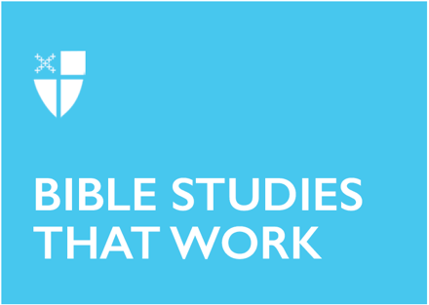
Epiphany 5 (A)
February 5, 2023

[RCL] Isaiah 58:1-9a, [9b-12]; Psalm 112:1-9, (10); 1 Corinthians 2:1-12, [13-16]; Matthew 5:13-20

The season of Epiphany is when we celebrate the revealing of Christ to the world. We mark the arrival of the One who is the light of the world: a light that brings life, a light that brings hope. This light shines its brightest when we are in community - with God and with one another.

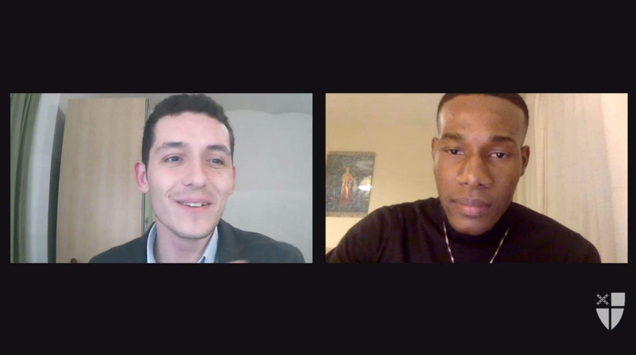
The Office of Global Partnerships of The Episcopal Church invites individuals, small groups, congregations, and dioceses to use our weekly video series throughout the season of Epiphany to draw closer to each other and our Lord. Using an adaptation of lectio divina with the gospel passage for each Sunday, you’ll meet and hear from Episcopal missionaries who have served around the world as they read and reflect on Jesus’ revelation to us. Missionary service through The Episcopal Church is accomplished through the Young Adult Service Corps (for Episcopalians aged 21-30) and Episcopal Volunteers in Mission (for Episcopalians over the age of 30). Learn more about these programs at iam.ec/yasc and iam.ec/evim respectively.

This week’s lectio divina features Joris Bürmann and Derby Guerrier. Watch their discussion at iam.ec/epiphany2023 and follow along by yourself or in a small group. To participate:

1. Read today’s Gospel passage:
Jesus said, “You are the salt of the earth; but if salt has lost its taste, how can its saltiness be restored? It is no longer good for anything, but is thrown out and trampled under foot. “You are the light of the world. A city built on a hill cannot be hid. No one after lighting a lamp puts it under the bushel basket, but on the lampstand, and it gives light to all in the house. In the same way, let your light shine before others, so that they may see your good works and give glory to your Father in heaven. “Do not think that I have come to abolish the law or the prophets; I have come not to abolish but to fulfill. For truly I tell you, until heaven and earth pass away, not one letter, not one stroke of a letter, will pass from the law until all is accomplished. Therefore, whoever breaks one of the least of these commandments, and teaches others to do the same, will be called least in the kingdom of heaven; but whoever does them and teaches them will be called great in the kingdom of heaven. For I tell you, unless your righteousness exceeds that of the scribes and Pharisees, you will never enter the kingdom of heaven.” (Matthew 5:13-20, NRSV)

2. Reflect: Which word or short phrase caught your attention or came to mind? Whether you’re alone or in a group, say it aloud.

3. Read: Reread the passage, perhaps in a different translation.

4. Reflect: Where does the passage touch your life today? If you’re with a group, share your responses with each other, without discussing further. If you’re alone, say your response aloud or write it down.

5. Read: Reread the passage, perhaps in yet another translation.

6. Reflect: Where is God calling you to go? Where, either near or far, can you cross boundaries, listen deeply, and live like Jesus? You might consider journaling out your response and meditating on it over the course of this week.

7. Pray: In closing, say the Collect for Epiphany 5 in the Book of Common Prayer (p. 216).

