Epiphany 6 (A)
February 12, 2023

[RCL] Deuteronomy 30:15-20 or Sirach 15:15-20; Psalm 119:1-8; 1 Corinthians 3:1-9; Matthew 5:21-37

The season of Epiphany is when we celebrate the revealing of Christ to the world. We mark the arrival of the One who is the light of the world: a light that brings life, a light that brings hope. This light shines its brightest when we are in community - with God and with one another.

The Office of Global Partnerships of The Episcopal Church invites individuals, small groups, congregations, and dioceses to use our weekly video series throughout the season of Epiphany to draw closer to each other and our Lord. Using an adaptation of lectio divina with the gospel passage for each Sunday, you’ll meet and hear from Episcopal missionaries who have served around the world as they read and reflect on Jesus’ revelation to us. Missionary service through The Episcopal Church is accomplished through the Young Adult Service Corps (for Episcopalians aged 21-30) and Episcopal Volunteers in Mission (for Episcopalians over the age of 30). Learn more about these programs at iam.ec/yasc and iam.ec/evim respectively.

This week’s lectio divina features the Rev. Joseph S. Pagano, the Rev. Amy Richter, Dr. Janet O’Flynn, and the Rev. Donnel O’Flynn. Watch their discussion at iam.ec/epiphany2023 and follow along by yourself or in a small group. To participate:

1. Read today’s Gospel passage, Matthew 5:21-37.

2. Reflect: Which word or short phrase caught your attention or came to mind? Whether you’re alone or in a group, say it aloud.

3. Read: Reread the passage, perhaps in a different translation.
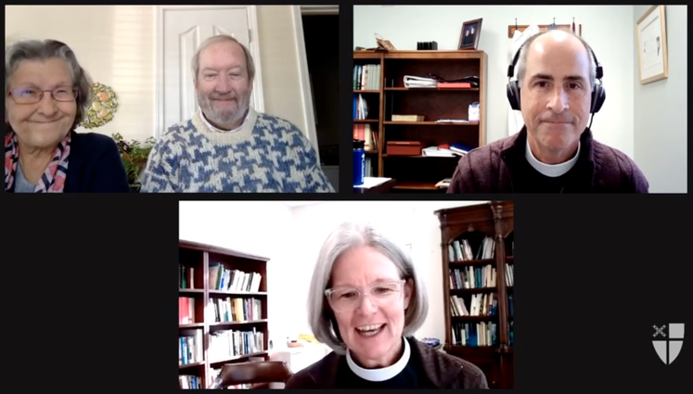
4. Reflect: Where does the passage touch your life today? If you’re with a group, share your responses with each other, without discussing further. If you’re alone, say your response aloud or write it down.

5. Read: Reread the passage, perhaps in yet another translation.

6. Reflect: Where is God calling you to go? Where, either near or far, can you cross boundaries, listen deeply, and live like Jesus? You might consider journaling out your response and meditating on it over the course of this week.

7. Pray: In closing, say the Collect for Epiphany 6 in the Book of Common Prayer (p. 216).

