February 12, 2023 – Epiphany 6 (A)

The Feast of Janani Luwum

Janani Luwum was born in 1922 at Acholi in Uganda, near the Sudanese border. After his early years as a teacher and lay reader in Gulu, he was sent to St. Augustine’s College, Canterbury. He was ordained priest in 1956 and returned to Uganda to assume responsibility for twenty-four congregations. After several years of service that included work at a local theological college, Luwum returned to England on scholarship for further study at the London College of Divinity.

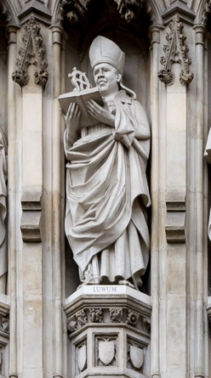
In 1969, Luwum became Bishop of Northern Uganda, where he was a faithful visitor to his parishes as well as a growing influence at international gatherings of the Anglican Communion. In 1974, he was elected Archbishop of the Church of Uganda, Rwanda, Burundi, and Boga-Zaire.
A statue of Archbishop Luwum at Westminster Abbey, one of the 20th century martyrs. Photo by CEphoto, Uwe Aranas
Luwum’s new position brought him into direct contact and eventual confrontation with the Ugandan military dictator, Idi Amin, as the Archbishop sought to protect his people from the brutality of Amin’s regime. In August of 1976, Makerere University was sacked by government troops. With Archbishop Luwum as their chair, the Christian leaders of the country drafted a strong memorandum of protest against officially sanctioned rape and murder.

In early February 1977, the Archbishop’s residence was searched for arms by government security forces. On February 16, President Amin summoned Luwum to his palace. He went there, accompanied by the other Anglican bishops and by the Roman Catholic cardinal archbishop and a senior leader of the Muslim community. After being accused of complicity in a plot to murder the President, most of the clerics were allowed to leave. However, Archbishop Luwum was ordered to remain behind. As his companions departed, Luwum said, “They are going to kill me. I am not afraid.” He was never seen alive again. The following day the government announced that he had been killed in an automobile accident while resisting arrest. Only after some weeks had passed was his bullet-riddled body released to his family for burial.

Early in his confrontation with the Ugandan government, Archbishop Luwum answered one of his critics by saying, “I do not know how long I shall occupy this chair. I live as though there will be no tomorrow... While the opportunity is there, I preach the gospel with all my might, and my conscience is clear before God.”

Collect for Janani Luwum, Archbishop and Martyr
O God, whose Son the Good Shepherd laid down his life for the sheep: We give you thanks for your faithful shepherd, Janani Luwum, who after his Savior’s example gave up his life for the people of Uganda. Grant us to be so inspired by his witness that we make no peace with oppression, but live as those who are sealed with the cross of Christ, who died and rose again, and now lives and reigns with you and the Holy Spirit, one God, for ever and ever. Amen.

Note: This brief biography of Janani Luwum comes from A Great Cloud of Witnesses, Church Publishing, 2016.

