March 19, 2022 – Lent 4 (A)
Week 4: Life Transformed – The Way of Love in Lent
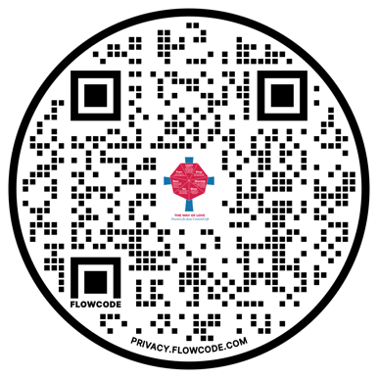
The journey through Lent into Easter is a journey with Jesus. We are baptized into his life, self-giving, and death; then, we rise in hope to life transformed. This Lent, communities are invited to walk with Jesus in his Way of Love and into the experience of transformed life. Together, we will reflect anew on the loving actions of God as recounted in the Easter Vigil readings. Together, we will walk through the depths of salvation history into the fullness of redemption. Throughout Lent, come along with us as we explore Life Transformed: The Way of Love in Lent, produced by Hillary Raining and Jenifer Gamber. You can find resources mentioned below at iam.ec/lifetransformed or by scanning the QR code to the right.

Week 4

Sunday, March 19
Today’s Practice: Watch the Rev. Dr. Hillary Raining’s video at iam.ec/lifetransformed for Week 4. The topic is based on the practice “Bless” and is titled, “A New Heart and a New Spirit”.
Read: Ezekiel 36:24-28

Monday, March 20
Today’s Prompt: What challenges are you facing today?
Read: “And you will have confidence, because there is hope; you will be protected and take your rest in safety.” - Job 11:18

Tuesday, March 21
Today’s Prompt: Where do you find joy and passion?
Read: “They said to each other, ‘Were not our hearts burning within us while he was talking to us on the road, while he was opening the scriptures to us?’” - Luke 24:32

Wednesday, March 22
Today’s Prompt: What can you say “no” to so you can say “yes” to prayer, rest and joy?
Read: “Six days shall work be done; but the seventh day is a sabbath of complete rest, a holy convocation; you shall do no work: it is a sabbath to the Lord throughout your settlements.” - Lev. 23:3

Thursday, March 23
Today’s Prompt: Practice lectio divina with this scripture.
Read: Luke 15:17-24

Friday, March 24
Today’s Prompt: Create a prayer representing how you seek to serve God and follow Jesus.
Read: “No one after lighting a lamp puts it under the bushel basket, but on the lampstand, and it gives light to all in the house.” - Matt. 5:15

Saturday, March 25
Today’s Prompt: How do others experience the love of Christ through you?
Read: “By contrast, the fruit of the Spirit is love, joy, peace, patience, kindness, generosity, faithfulness, gentleness, and self-control. There is no law against such things.” - Gal. 5:22-23

Reflections from “Living the Way of Love” by Mary Bea Sullivan (Church Publishing, 2019). Used with permission. Quotations from the New Revised Standard Version Bible, copyright © 1989 the Division of Christian Education of the National Council of the Churches of Christ in the United States of America. Used by permission. All rights reserved.

